MSI Repeat Photography Forest Health Sites
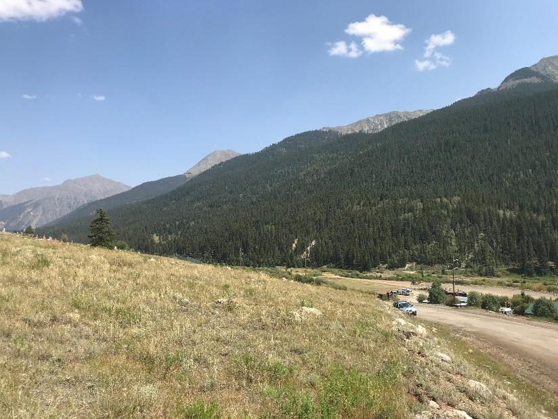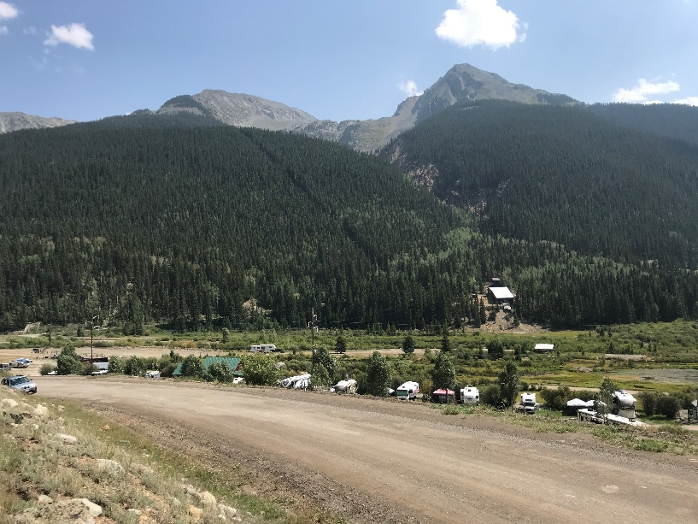
Kendall (outside plot), facing E Kendall, facing SE
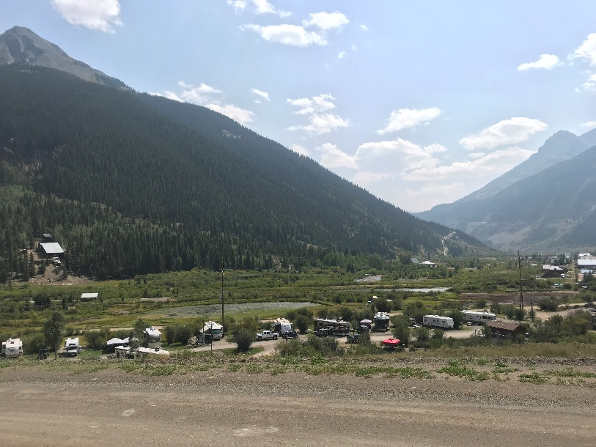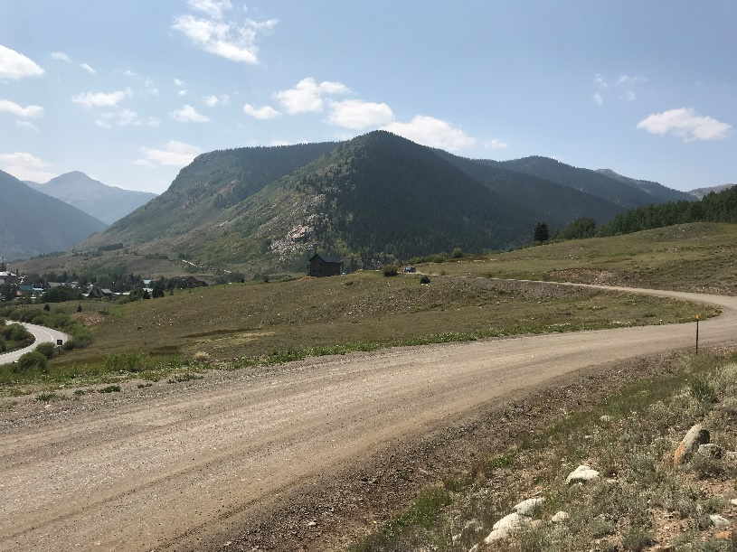
Kendall, facing S Kendall, facing W
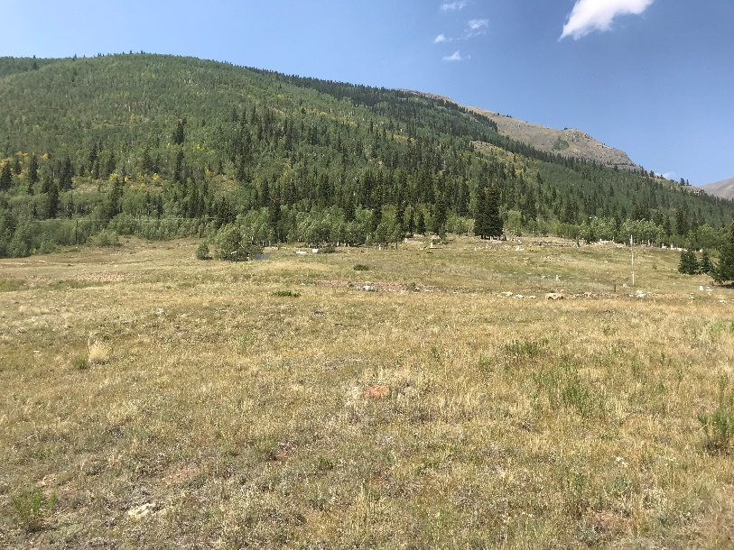
Kendall, facing N
Kendall (Outside Plot): on rock near top of road cut (orange dot hidden on rock), Lat: 37.81792, Lon: -107.65391. SE faces FHS01 plot.
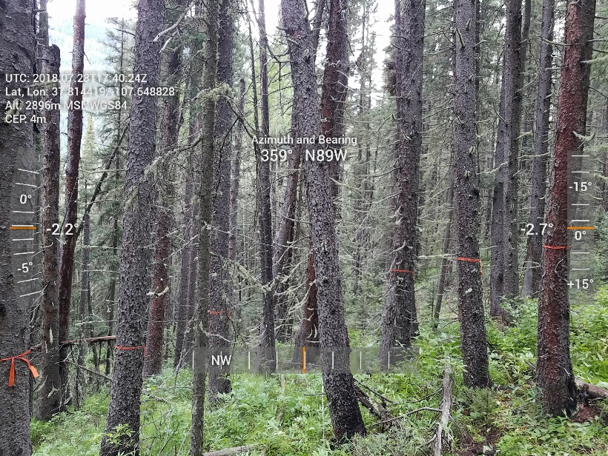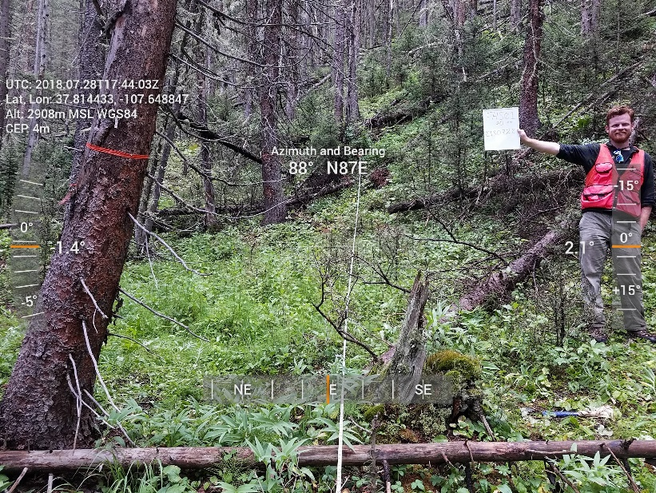
Kendall Plot, facing N Kendall Plot, facing E
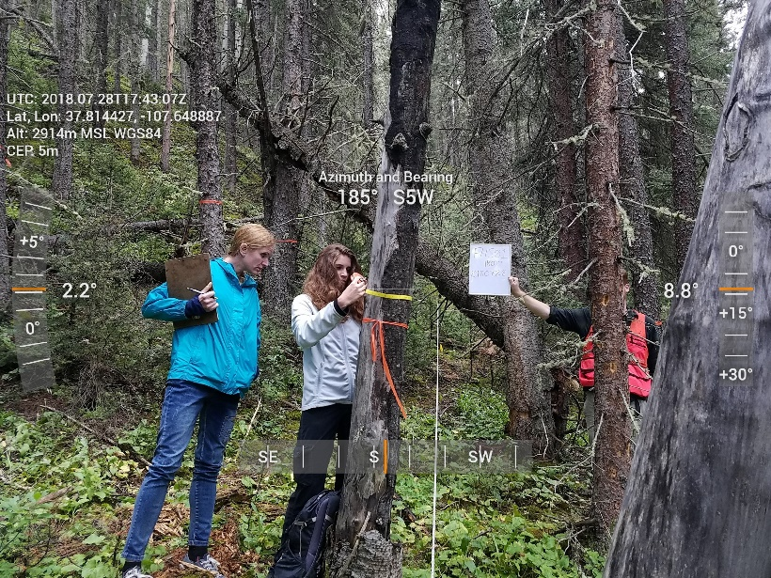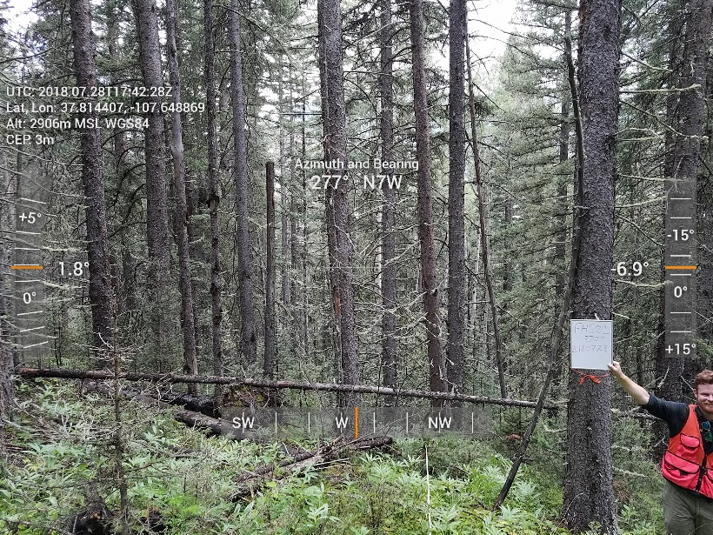
Kendall Plot, facing S Kendall Plot, facing W

Kendall Plot (FHS01): Up trail from Kendal Mtn. Center, past the Lackawanna Mill site. Lat: 37.81467, Lon: -107.64890

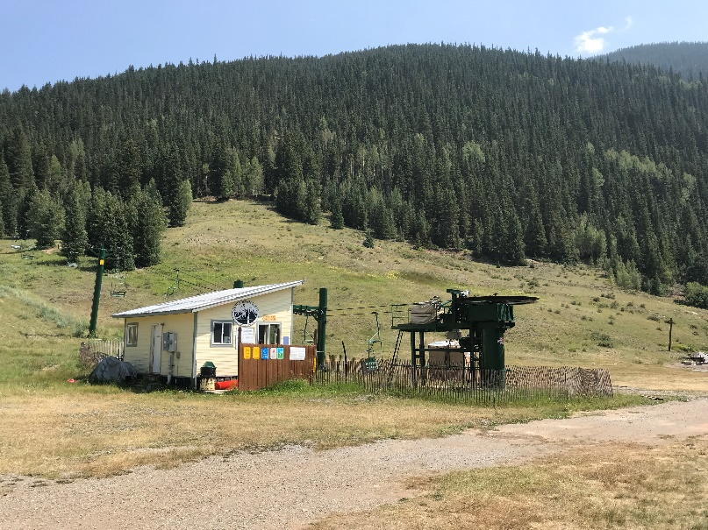
Kendall Lift, Facing ~SW from structure corner

Kendall Lift: taken from NE corner of small structure Lat: 37.81131, Lon: -107.65675
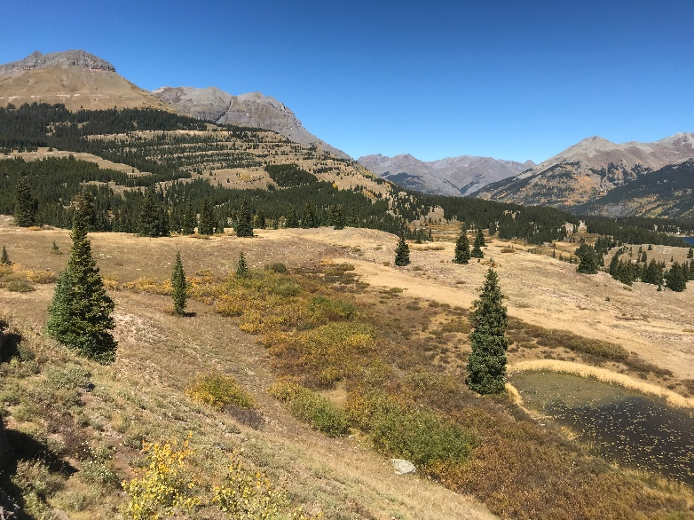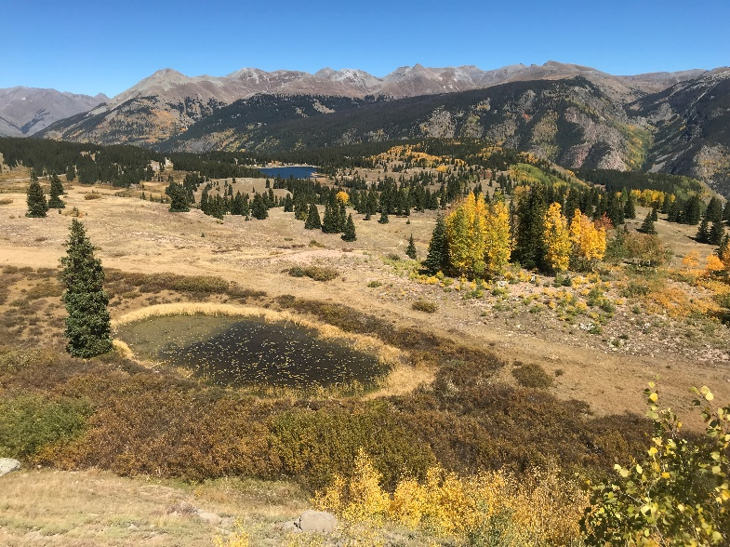
Molas Pass facing N Molas Pass facing NE (toward cit sci plot)
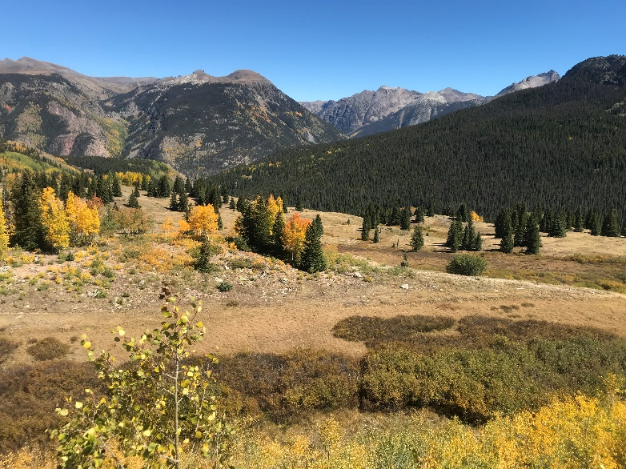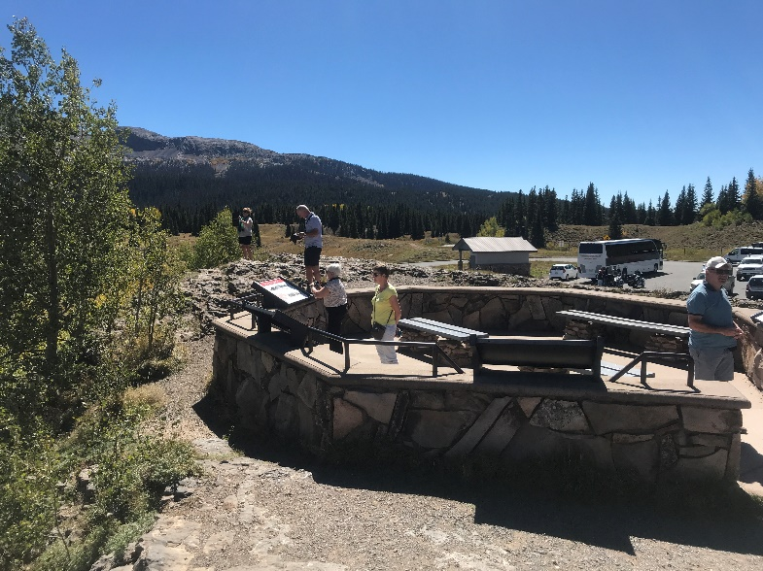
Molas Pass facing E Molas Pass facing S
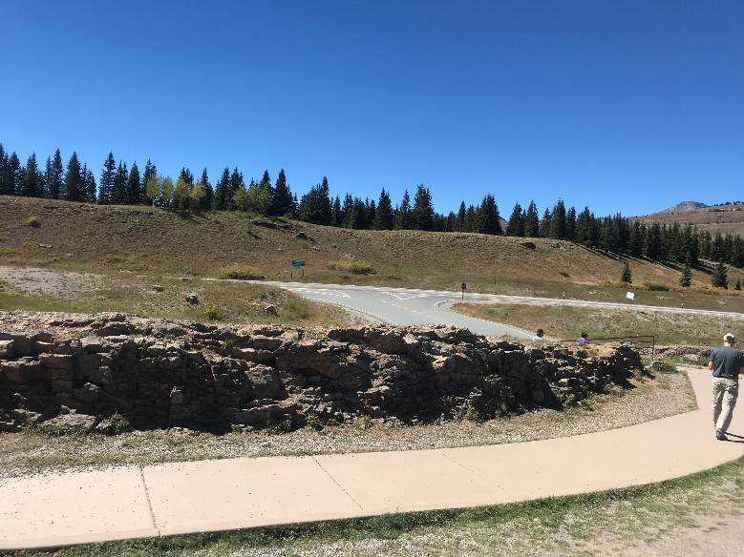
Molas Pass facing W

Molas Pass (outside plot): Main pullout lot, just N of interpretive circle at lookout, on rock. Lat: 37.73757, Lon: -107.69689
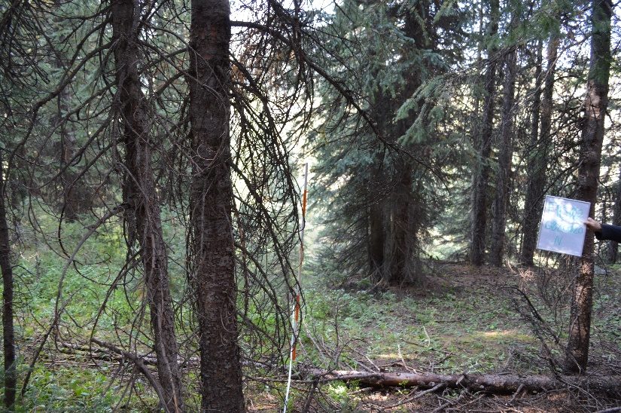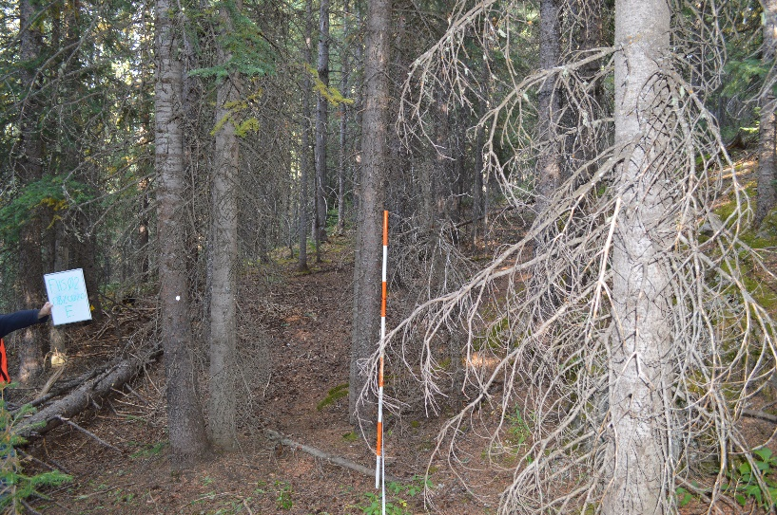
Molas Plot (FHS02), facing N Molas plot (FHS02), facing E
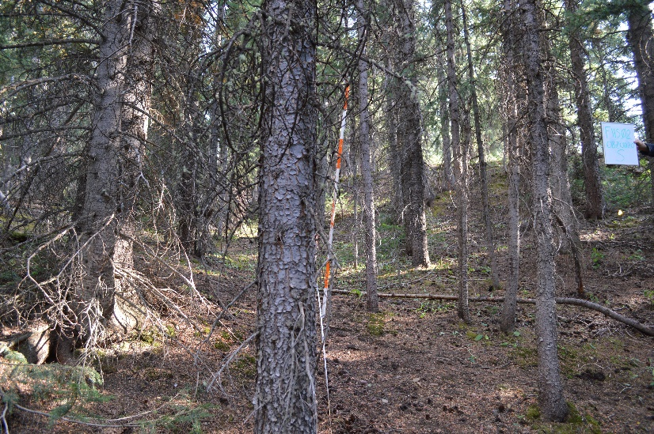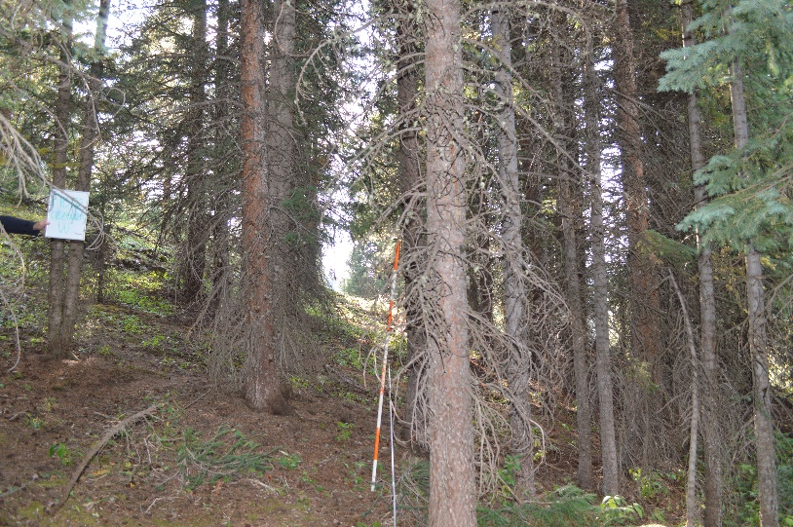
Molas Plot (FHS02), facing S Molas plot (FHS02), facing W
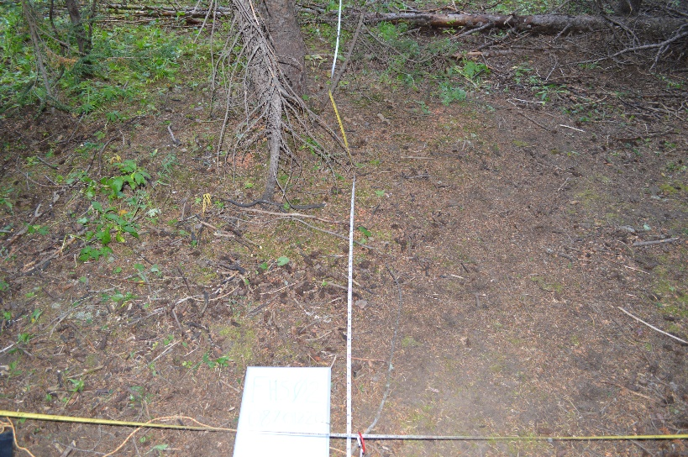
Molas Plot (FHS02), facing the ground looking N

Molas Plot (FHS02): Taken from plot along Colorado Trail Lat: 37.74158, Lon: -107.69079

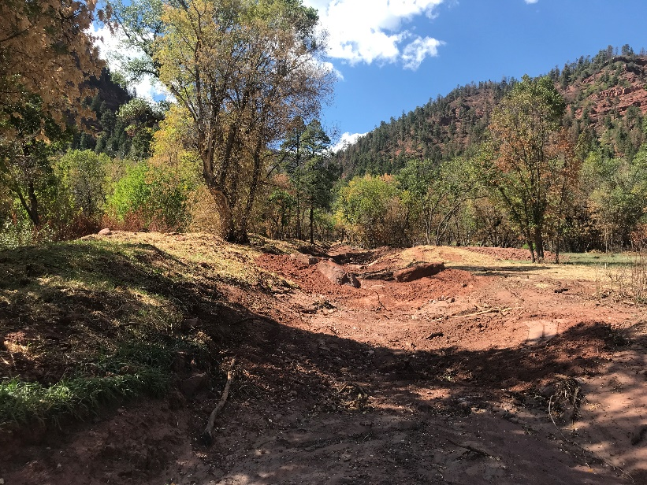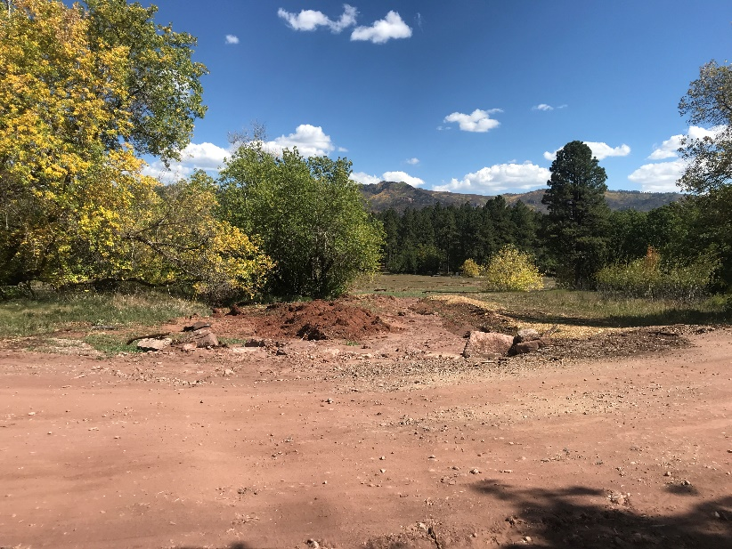
Dyke Canyon, facing upstream (290) Dyke Canyon, facing downstream (110).

Dyke Canyon: Lat: 37.38899, Lon: -107.86794, facing upstream (290 degrees) and downstream (110 degrees), in Falls Creek HOA
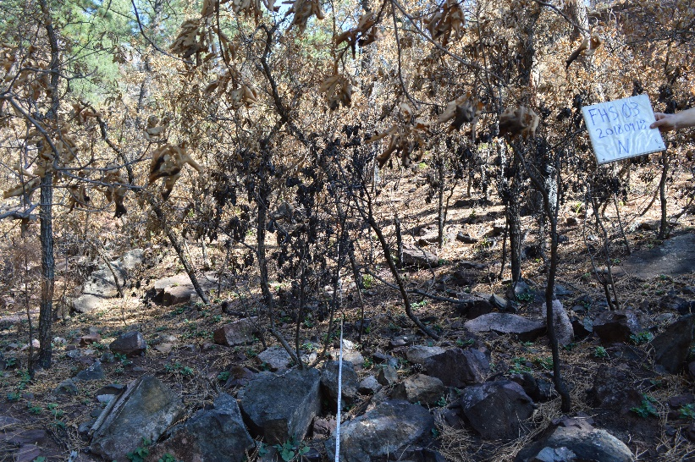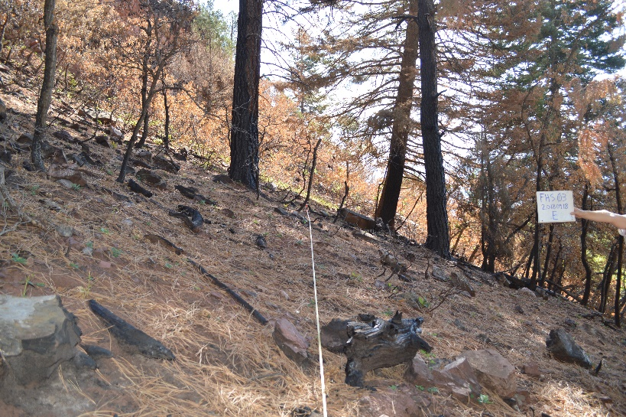
Falls Creek-burned (FHS03), facing N. Falls Creek-burned (FHS03), facing E.
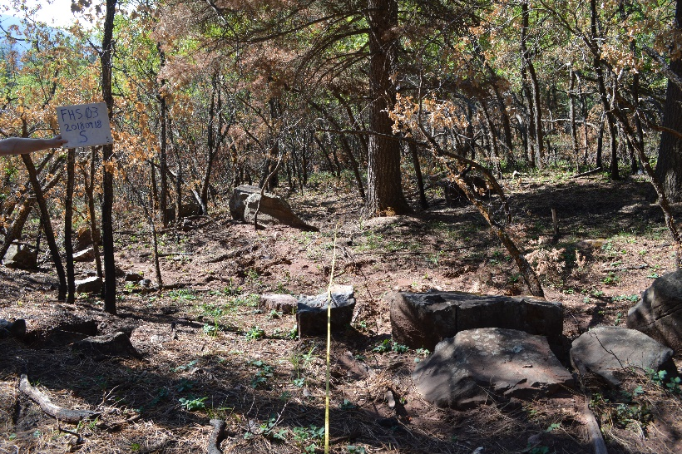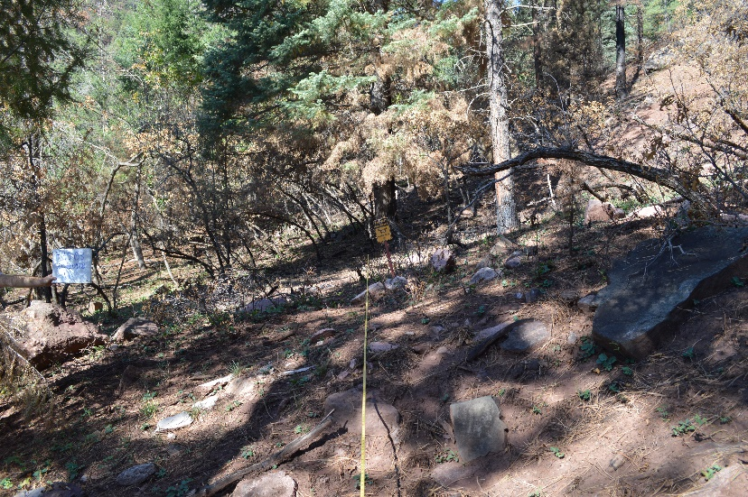
Falls Creek-burned (FHS03), facing S. Falls Creek-burned (FHS03), facing W.
Falls Creek- burned (FHS03): Plot up Dyke Canyon from road. Lat: 37.39167, Lon: -107.87206
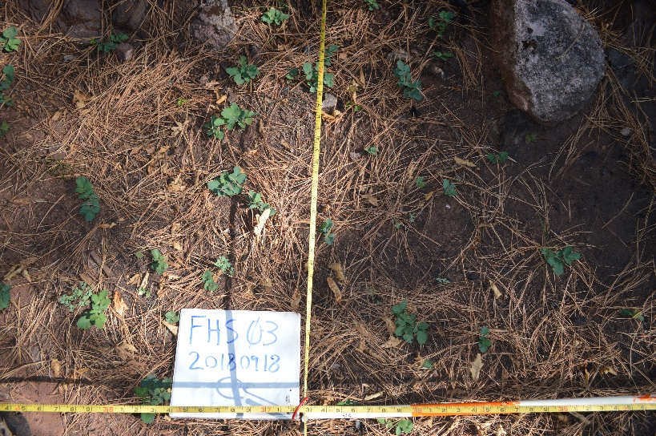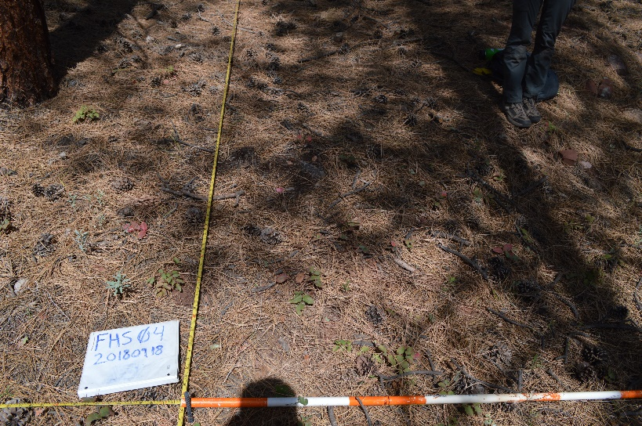
Falls Creek-burned (FHS03), facing the ground looking N Falls Creek-unburned (FHS04), facing the ground looking N
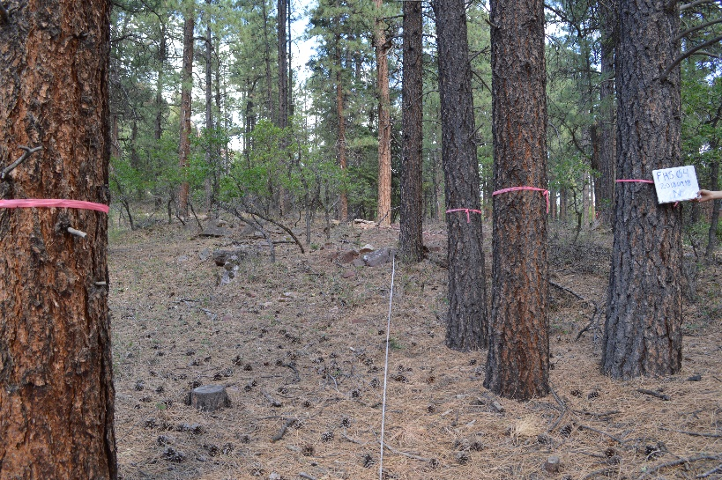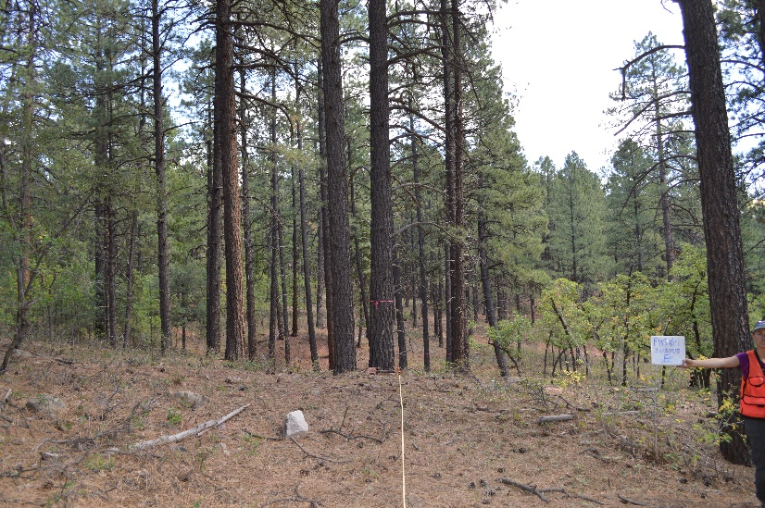
Falls Creek-unburned (FHS04), facing N. Falls Creek-unburned (FHS04), facing E.
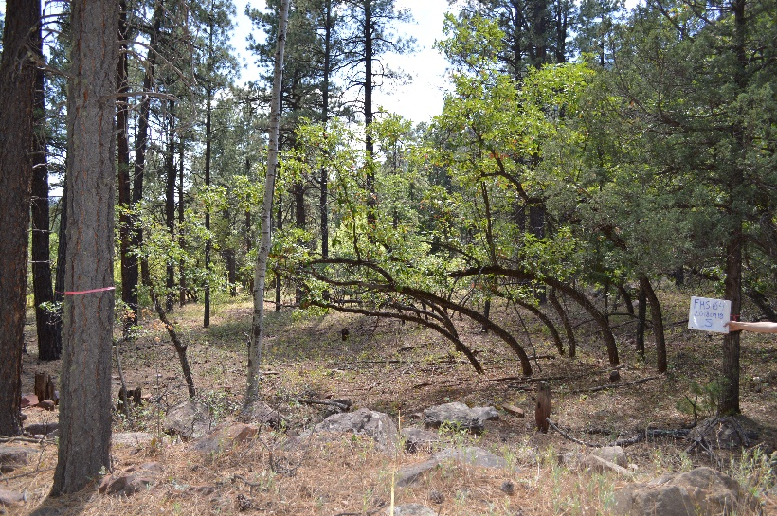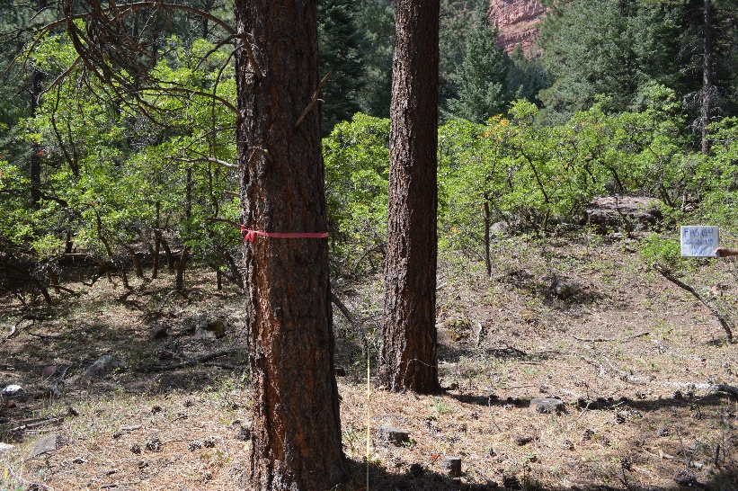
Falls Creek-unburned (FHS04), facing S. Falls Creek-unburned (FHS04), facing W.
Falls Creek- burned (FHS03): Plot up Dyke Canyon from road. Lat: 37.39167, Lon: -107.87206
Falls Creek- unburned (FHS04): Plot on right along road before reaching Dyke Creek. Lat: 37.38639, Lon: -107.86904

