Upper San Juan Watershed Enhancement Partnership
MEETING NOTES

STEERING COMMITTEE MEETING: February 12, 2021

Attendees: Al Pfister, Joe Crabb, Tobi Rohwer, Becca Smith, Mely Whiting, Aaron Kimple, Mandy Eskelson

Updates & Partner Check-In
- Mesa Canyon takeout: Town applied for $10k CPW grant and multiple partners involved in discussions with Archuleta County about tourism infrastructure, cost estimates and outline potential construction/implementation timelines in the fall after high water. Possibility of receiving additional funds from Trout Unlimited and Tourism Board. If all funding comes through the project will be fully funded.
- MSI posted project on social media and received some negative feedback that our organization and the project is promoting overuse/damage to the river. Directed further discussion to project leads. Hoping to highlight this project work would be protecting use that has been happening for over 40 years and will improve safety with appropriate parking and ramp takeout structures, reduce bank erosion.
- San Juan Water Conservancy Board: WEP’s name was mentioned in Pagosa Sun article couple of week’s back. Rest assured, this group is still in good standing with SWCD and has come up with game plan moving forward so no questioning of WEP or Al’s multiple roles in community groups.
- MSI happy to provide budget updates to any partner or funder requests. Normally rely on grant reports available to anyone, including general public, to provide financial information, but option to provide other information based on board/funder request. For mid-grant payment details, may take finance team additional time to compile most recent data.
- Either Mandy or other WEP representative will put in requests for agenda items (e.g. presentations, letters of support for grant applications, etc.), ideally with ample notice.
- Mandy provided presentation on Phases II and III to board in fall of 2020, but good idea to offer another board presentation in 2021 to provide update and detail more about Phase III tasks and outcomes.
- Wilson Water Group report coming soon: part of SJWCD’s diligence regarding West Fork water rights. WWG will provide draft report at next SJWCD meeting and should be finalized around end of the month. Report involved demand analysis of different uses within upper San Juan. WWG spoke with Seth Mason on his work with WEP and discussed potential connections and data.
- Pagosa Wetland Partners-Ad hoc committee affiliated with Weminuche Audubon interested in reducing potential impacts to Riverwalk Wetlands from expansion of Springs Resort complex. Group reconnected with us to provide update on their overall goals and different roles folks are playing. Have made no formal requests of WEP, but open to collaboration. Quote: “Any and every contribution of insight, information, data, perspective, or assistance is valued and welcome.”
- Group Contacts/Roles/Tasks they passed along:
- Randy McCormick (retired hydrologist/environmental management) conducting preliminary risk assessment, monitoring protocol, updated management plan with proposal from Ecosphere Environmental Consulting due to their previous work on this site and solid base of data.
- Barry Knot (outreach/land use code)-involved with group providing input on Land Use Development Code (LUDC) for the Town of Pagosa Springs.
- Conversations with David Dronet, the current project lead for the Springs Partners LLC, in hopes of preserving wetlands and supporting business. Springs Partners own the warm water rights that feed the wetlands as well as some of the land that underlies the wetlands.
- Community values/benefits to consider for project identification and prioritization in Phase III: Randy mentioned Springs Partners showed interest in having interpretive tours of the Riverwalk Wetlands available to their customers, which Weminuche Audubon volunteers may be able to provide. Also interest from teachers to use the wetland complex as a location for outdoor science education.
- Outstanding Waters group update:
- Coalition of organizations exploring options of Outstanding Waters designations in the San Juan and Gunnison Basins, with triennial review coming up for this area. Mandy only aware of few details because MSI was hired as subcontractor to collect water quality samples and compile data, but have no role in the outreach or advocacy of such efforts. Mandy will ask the group to provide list of who is involved and info on process, potentially offer presentation to WEP steering committee in future if so desired.
- Basic info so far:
- Sites located upper San Juan River area near Fall Creek, Wolf Creek, and Quartz Creek. Other San Juan Basin sites being explored are in Animas watershed and over in Gunnison.
- Forest service is aware of this group and has helped with permitting for sampling since this may affect future management.
- Designation is an antidegradation water quality protection from the Colorado Water Quality Control Commission, if groups show the site meets 3 criteria: meets or exceeds certain parameters, possesses outstanding natural resource value (e.g. fish habitat, clean water contributions), and requires further protection than that already provided by water quality regulations.
- Must have stakeholder engagement and buy-in as well in order to qualify. Something to consider in Phase III planning.
- Draft Phase II reports from Lotic and SJCD:
- Originally goal for end of February, but now aiming to have draft report by end of April.
- At Feb. 16th meeting with Seth, group decided it would be better to incorporate feedback from the March public meeting into the report, based on impressions/questions on presentations and graphs rather than a formal document that has public comment/revision period at this stage in the project.
- Formal public comment/revision process is recommended/necessary for Integrated Water Management Plan in Phase III though.
- Compiled information on assessment results will be ready for public meeting at end of March, just not formatted into report document to go through line-by-line.
- Board/organization presentations to schedule in 2021:
- Group recommends relying on SJCD’s good relationships to time and present on WEP and the agricultural infrastructure inventory results to ditch companies and individual property owners, highlighting that this group can help with funding improvements, if they decide to proceed with a project.
- Other presentations for WEP representative to consider, with brief overview of WEP, Phase II results, and how to be involved in Phase III.
- HOA meetings: Navajo River Ranch, Crowley Ranch, Lower Blanco POA
- Tourism Board, Town Council, County Board of County Commissioners

Phase II Public Meeting Planning
- Themes: discussed topics to highlight in public meetings, keeping in mind that we are not obligated to bring in any guest speakers or touch upon other topics other than what the WEP, Lotic, and SJCD have been doing in Phase II and hope to do in Phase III. Bring in other speakers/topics only if it puts efforts into context, highlights partner/committee member efforts, and/or adds to the discussions.
- Date recommendation: evening of March 31st from 5:30-7:30 pm to avoid springs breaks and other public events in April.
- Comments: Hydrologist presentation from DWR would be repetitive of Seth’s work. Recommend instead having Joe giving a bird’s eye view to provide context rather than details of water administration in the San Juan, avoiding big discussions on drought, conservation. Next, have Justin discuss what plans and actions PAWSD has in place to handle drought conditions, then Seth and Cynthia discuss Phase II results.
- Stakeholder email list: Mandy will send out current WEP stakeholder email list to see what other contacts and groups we should consider sending meeting flyers and info.
- Feedback collection: For upcoming public meeting, mainly inquiring about comfort and confidence levels with the results/information provided by Seth and Cynthia from the general public and decision-makers’ (e.g. do irrigators, conservancy districts, agencies, recreators believe hydrologic results are accurate/probable).
- Main Purposes: provide general presentation of what models or assessments showing and discuss options to provide future meetings or workshops to go into more detail, depending upon interest and needs of stakeholders.
- Questions to ask (Mandy to draft list of questions and polls to survey during meeting):
- How do stakeholders imagine we make these results/info actionable?
- What does this report need to look like so this gets work done on the ground? Get folks thinking about projects and create a repository/inventory for these ideas.
- other topics stakeholders’ interested in learning about in future meeting
- Describe what next meeting may look like so they start thinking about what breakout sessions should focus on, what info they need to keep in mind to be prepared.

Phase III Update
- Funding review:
- Majority of Phase III funding secured: Received approval of 2 major grants (CWRP and Basin WSRF), waiting on Statewide WSRF approval (CWCB meeting 3/11). Of our 9 match fund sources, we have secured commitment from 7 sources.
- Some cash match sources changed due to increases or decreases in funding awards as well as desire to pursue most secure sources rather than new Forever Our Rivers Foundation grant MSI initially put in grant applications.

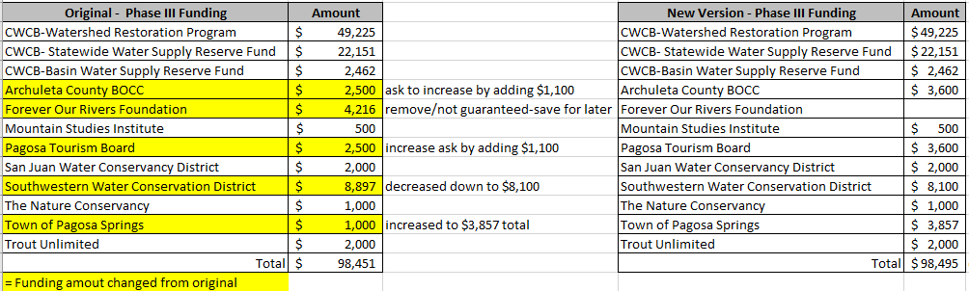
- Forever Our Rivers Foundation: MSI currently becoming partner with new org so we’re able to apply to grant program on behalf of collaborative groups we work with and/or MSI projects. Mandy still advocating WEP apply for this grant if we determine demonstration project or other tasks we’d like to add this year, but not use it as uncertain cash match source.
Grant Priorities and types of projects Forever Our Rivers funds below
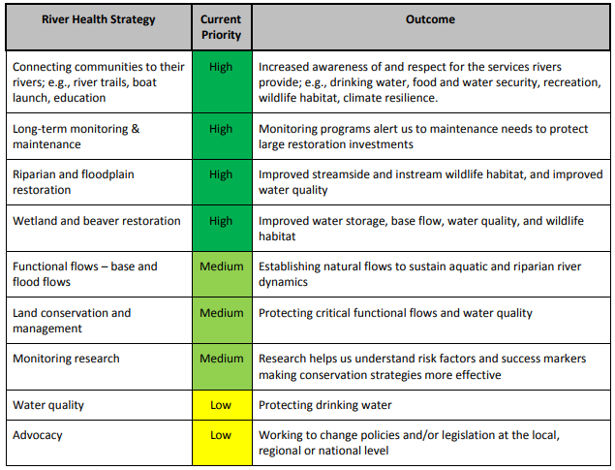
- Potential demonstration projects discussed:
- PAWSD/SJWCD property-Running Iron Ranch: Longer timeline (current lease expires Jan. 2023) but location group members are still interested in, with strong interest from Town and CPW.
- Actions: encourage discussions to determine roles between Town and CPW (property ownership, management, funding structures like easements, Habitat Stamp, others?) and how WEP can help with outreach, design plans, funding.
- Any interested parties from SJCD inventory looking to make immediate infrastructure improvements
- Stream gauges:
- potential for historical gauge site on West Fork since there is historical data, infrastructure in place, past site of wildfire, and forest restoration work up there to investigate some of those impacts on watershed health, whether increasing water availability up there. Not sure about benefits of East Fork gauge though. May be beneficial to have fork gauges to help with modeling and extrapolation to help create mainstem forecasts. Gauges may support that forest-water connection via data monitoring of watershed health impacts from forest treatments/management.

Conclusion/Next Meeting
- MSI is obligated to follow state COVID-19 guidelines per grant contracts, but we are closely monitoring changing COVID-19 guideline levels to keep in mind when the group may be able to have a safe in-person public meeting in the future, with recognition community feedback gathering can be easier, more valuable, larger group with an in-person setting.
- Steering Committee invited to attend meeting with Lotic/SJCD: Tuesday, March 16th 1-2 pm
- Main meeting focus: finalize Public Meeting schedule and presentation flow
- Phase III-may recommend moving meetings with Lotic/SJCD from 2nd Tuesdays each month to occur every 2nd Friday morning or other day to keep more consistent schedule. Fridays may be difficult though since Cynthia is not usually available on Fridays.
- Phase III grants setup to continue every other month steering committee meetings, but easier to track if all types of meetings on same day/time with option for committee to participate. Potential schedule setup could be 1st hour-discuss project details with Lotic and SJCD, 2nd hour-discuss any other committee topics or tasks
- Public Meeting: Wednesday, March 31st 5:30 to 7:30 pm
- May/June: ideas for steering committee field trip with small group, outside?

Highlights/Resources from Feb. 16th Meeting with Seth Mason/Lotic
- Public meeting will be an introduction to the types of deliverable this process will offer, and we need to ask stakeholders what they need to interpret and use these results.
- Deliverable options to consider:
- Final Report/Integrated Water Management Plan with project cutsheets formatted to be easily added to Colorado Water Plan and Basin Implementation Plan Identified Projects & Processes (IPPs) list. (Guaranteed as part of Phase III funding)
- Links to ArcGIS map in Appendix with spatial data by theme (e.g. map layers showing fire risk, sediment deposition). (Option to add to report and website)
- StoryMap with executive summary, maps, and potentially “decision support tools”
- Would not necessarily need to add new task request from Seth/Lotic to create StoryMap. MSI included StoryMap in Phase III deliverables to show WEP efforts and tie to other groups like San Juan Headwaters Forest Health Partnership, making it easy to add maps and links created by Lotic.
- Discussion on how stakeholders will be able to access data and models:
- Rather than have a generic database, it may be better to determine what specific questions users have to answer with models and build functionality and datasets around that. WEP should incorporate these types of questions into public meetings/workshops/discussions.
- Consider-Decision Support Tools
- Map-based applications-example where you can click on headgate, segments and explore shortage projects under different climate scenarios.
- Forecasting tools/examples of tools Lotic has developed for:
- American Whitewater on Gunnison (still being developed): Boatable Days tool
Input=choose user group, river section, year type (wet, dry, average). Output=shows hydrograph, threshold graphics, and tabular data.
- Roaring Fork Conservancy Fryingpan River E-flows
- StoryMap (project overview)
- Streamflow Forecasting Tool
- Stream Temperature Tool
- Discussion on types of tools needed in this process:
- Tools that live beyond the life of a project that bring relevance to future decision making (e.g. final plan and project list that entities can use to pursue funding/support after these phases).
- Tools that address stakeholder questions and inform discussions on what kinds of actions needed (e.g. tools that help with project prioritization and mapping)

