**Upper San Juan Watershed Enhancement Partnership**

**MEETING NOTES**

**COMMITTEE MEETING:** April 12, 2019

**Where**: Town Hall Courtroom, Pagosa Springs, CO, 9 am – 11 am

**Action Items**

* **Schedule & coordinate May field trip to project option sites** (MSI & Steering Committee)
* **Send Report Review to Steering Committee on April 19th for review** (Al & Mandy)
* **Begin approaching site contacts/boards** (Al & Pat)

**9:00 – 9:10 Welcome & Introductions**

**9:10 – 10:10 Mapping Exercise/Project Options**

* Marking constituency concern/point-of-interest areas from each representative
* Goal: move something on the ground that creates opportunities for all interests (ag, enviro, rec, municipal), and creates a “triple bottom line” of improvement that benefit economy, communities, and habitat.
* Examples: Irrigation efficiency (Mely may have pipe project video to share), remove/adjust fish barriers, stream restoration, public access, data from stream gauge, etc.
* Addressed stream gauge is no longer 1st option due to concerns with costs of operation and maintenance, but some Steering Committee members would still like to keep it as an option
* Create range of options to show public on the various projects considered & weighed by Steering Committee, giving public something more tangible to give feedback on and see potential impacts (benefits & costs)
* Mapping exercise: Sticky dots marked on map showing current & prospective projects, show overlap and where all interests may be addressed
* Sticky dot color key:
* Green=Agriculture
* Blue=Environmental
* Orange=Recreation
* Magenta=Municipal

Purple=completed/ongoing

* 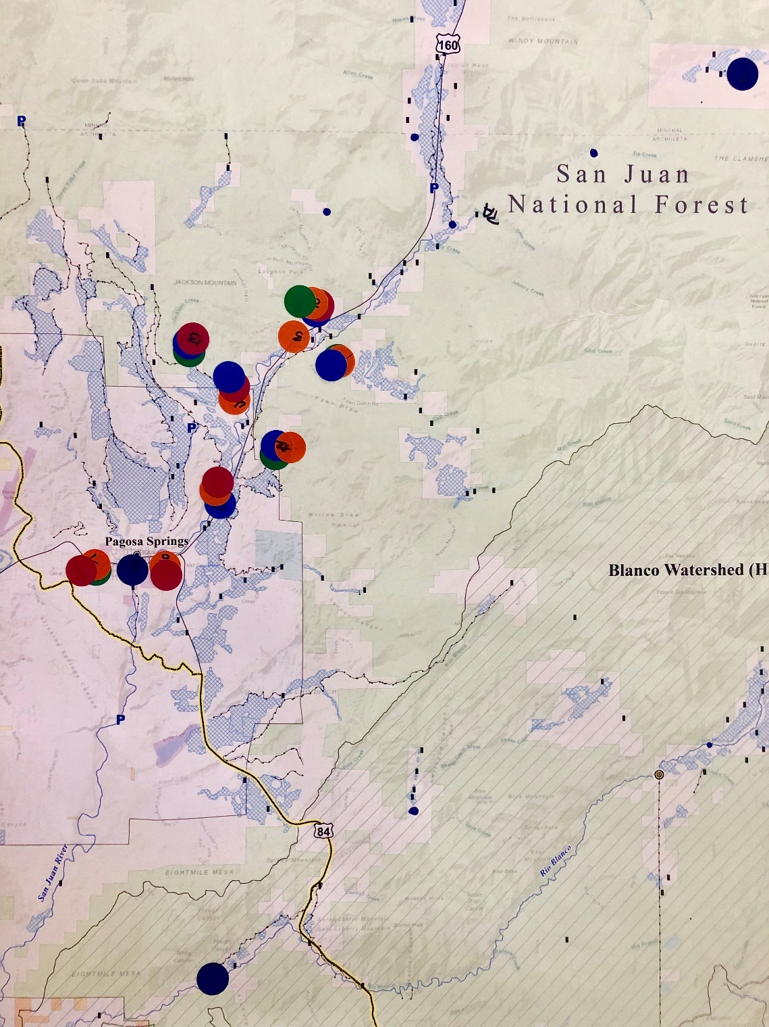Green (Agricultural) Infrastructure improvements.
* Blue (Environmental)
* Extend riparian habitat/restoration from Town boundary up to access point. Also adds recreational value.
* Orange (Recreation)
* Considerations: lack of public access, mainstem ditch diversions impacting recreation flows, in-channel improvements, possible upstream land swap for downstream public access, fishing recreation and diversion improvements.
* Magenta (Municipal)
* river access, recreation opportunities, municipal park/river center, extend river path.
* Challenges: Difficult to garner community participation and interest until we have a demonstration project with benefits established.
* Demonstration Project location options: tourism sector examples, Lower Blanco restoration projects, others?
* Other mentioned options or considerations:
* Possible to do private related project (ditch companies or diversions) that has second hand benefits to public if there is a combination of downstream access, fisheries, instream, etc. Attractive for public buy in and funding.
* Currently, there is very limited public access/park where people can experience river.
* Complicating factors of HOA projects with time and cost to negotiate, implement, etc.
* Gauge may be still appealing for unbiased data, even with O&M costs.
* Don’t limit the group to only one ditch company, since other ditches within the watershed may want to be involved.
* Projects involving boating access and trout habitat may need to clear hurdles of technical analysis first by getting CPW input on fish data, conceptual write up of fish needs, and what are the barriers/temps/flows.
* Group status: making great progress to already be talking about realistic, potential projects for all uses. Technical analysis in second phase can greatly assist in identifying priorities, vulnerable areas, most efficient use of money, and providing benefits to all groups.
* Next meeting, we need to talk about what Phase II could look like and need to get public feedback/buy-in.

**10:10 –10:30 Targeted Engagement**

* Create list of private landowners, ditch companies, HOAs, others
* Approaches: How to address each group? Hard sale (specific project) vs. soft sale (just to get them involved, build curiosity)

**10:30 – 10:50 Public Engagement Strategies**

* Timing and goals of future public meeting
* Possibly have midsummer (July) public meeting to discuss project options and gather input/feedback.
* Potential to combine with other local events/groups (movie night, raffle, food/beverage?)
* Outreach ideas for both targeted and public audiences
* Identify topic areas to present & which method (newspaper, radio, etc.)
* Possibly create short survey to ask public to identify project sites
* Or write up on Steering Committee considering options with photos of field trip

**10:50—11:00 Conclusion/Next meeting**

* Discuss summer availability:
* Poll Steering Committee members on field trip date week of May 6-11
* Field trip: drive along the San Juan, looking at riparian conditions, access, and diversion structures.