Upper San Juan Watershed Enhancement Partnership
MEETING NOTES

STEERING COMMITTEE MEETING: June 12, 2020 9 – 10 am
Where: Zoom Conference Call

NEXT MEETINGS:
  - Early August—Steering Committee field trip to Banded Peak Ranch

Attendees: Tim Haarmann, Joe Crabb, Aaron Kimple, Al Pfister, Ryan Unterreiner, James Dickhoff, Mely Whiting, Mandy Eskelson

Updates & Partner Check-In
- Great Outdoors Fund: GOF requested more data and should be posting project on funding website soon.
- 2nd project option of possible new river access and educational park area
- Need to develop short and long-term strategies for management (i.e. Town/business collaboration for short-term, possibly CPW for long-term vision) due to long process of getting agency management.
- Potential to apply for CPW Non-Motorized Trail Grant for river trail in area to help cover planning and construction costs. Application period from August – October 2020. Ryan reached out to DNR contact to inquire if possible to submit application for river trail to facilitate river access to relieve congestion and recreational pressure on the Town of Pagosa Springs segment of San Juan River. Learn more about program at https://cpw.state.co.us/aboutus/Pages/trails.aspx and https://cpw.state.co.us/aboutus/Pages/TrailsGrantsNM.aspx
- Town Council: WEP was fortunate to have our application approved for amount of $1,182. This is a reduced amount from the originally requested $2,500 ($1,318 short) but receiving approval during the COVID-19 economy is a big win.
- Tourism Board: Agreed to uphold their commitment for full amount ($2,500) WEP applied for. Tourism Boards requests invoicing after August for the board to have better grasp on summer tourism revenue.
- New Park Ditch representative option: Pat Bennett will be unable to participate in WEP for a while, if not indefinitely, as he will be moving for work. New option for a Park Ditch Company representative on committee suggested Vernon Lesley. Tim and Joe will make the introduction and explore his interest and availability, with backup options discussed, if needed. WEP may base steering committee schedule meeting time around this new member’s needs as well as others who have been unable to regularly attend in the past.
- Engagement/interaction with Bootjack Ranch: committee discussed when and how to involve this major stakeholder in area and will continue to explore how best to approach. Joe mentioned several contacts available, if needed.

San Juan River Improvement Project
- Board Meetings: did not occur, but WEP received some initial feedback from a few property owners, mostly positive about Concept Design Plans, with most concerns about river access on south end of subdivision.
- Al will attend future meetings when they occur to give brief overview and address any questions. POA meets mid-July, Metro the following week.
- Initial feedback to address:
- Emphasize public benefit needed to use grant funding to improve private property sections, but how this looks is still very much open for discussion and suggestions.
- How to limit/control public river access (i.e. who manages admin, open during optimal flows for recreation/seasonal, locked and/or gated access, permits)
- How to cover operations/maintenance costs (i.e. fees)
- Ask for list of questions both boards would like WEP to address and bring forward possible options.
Public Meeting Debrief
- Feedback & suggestions for 2nd public meeting
- Good turnout for online event in this area, but still difficult to make accessible to everyone, especially those who may not have easy internet access.
- In-person option available, if possible, for next public meeting. Potentially radio recording and more advertisement.
- 2nd Phase II Public Meeting topics: Survey results show interest in learning more about Colorado water law, hydrology basics, and unique species along San Juan and its tributaries.
- Survey results & winners
- Only 10 participants so far, so please continue sharing the website link widely https://www.surveymonkey.com/r/HGNL3RD or on website at http://www.mountainstudies.org/sanjuan/smp
- Three survey participant names were randomly selected using the tool https://namepicker.net. Winners Pam McGivern, Shane Jones, and Robert Ricketts received a $25 gift certificate from Pagosa Brewing Company for sharing their feedback. Al will be sending out certificates to winners via postal service or in person.
- Full results will be shared at next meeting, but here are some initial results:
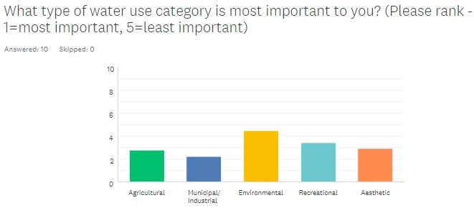
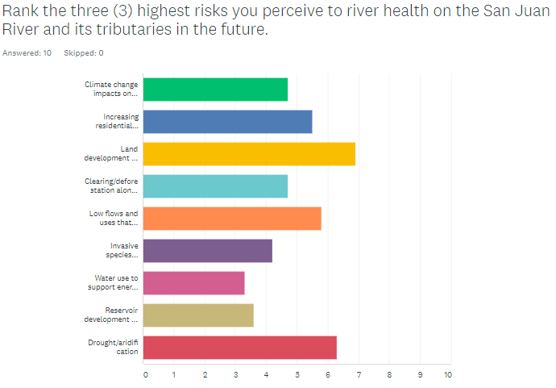
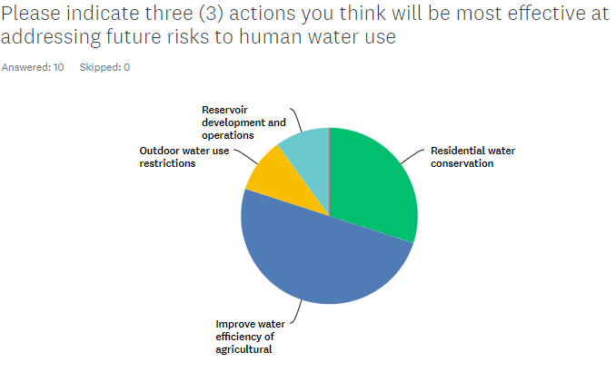

Conclusion/Next Meeting
- Next Meeting in August—field trip options (should be outdoors and less than 10 people, if we can)
- Banded Peak Ranch: view/discuss irrigation structures, forestry treatments, fish habitat, stream gauges. Option to invite hydrographer from DWR.
- Four Mile: Jim White (CPW biologist) to discuss San Juan cutthroat trout lineage and habitat
- Steering Committee meets every other month.
- Option 1: maintain every other 2nd Friday morning 9-11am
- Option 2: new day, Fridays not the best for James
- Option 3: new time, Mely prefers afternoon and may work better with Becky Guilliams’ teaching schedule
- Will try to accommodate new Park Ditch representatives schedule as well to ensure WEP maintains agricultural interests and concerns in planning and discussions.
- CWCB requiring grant recipients to follow state COVID-19 guidelines, especially reducing in-person gatherings and unnecessary travel.
- WEP will follow these restrictions by continuing to meet remotely for more meetings, but if travel or in-person meetings required for project needs, must encourage mask wearing, social distancing, small groups, held outdoors, separate vehicles, etc.
- CWCB travel restrictions should not interfere with Lotic and San Juan Conservation District’s Phase II field work.

