Upper San Juan Watershed Enhancement Partnership
Meeting Notes
STEERING COMMITTEE MEETING: September 6, 2019 10 am – 12 pm
Where: Town Hall Courtroom, Pagosa Springs, CO

NEXT MEETINGS:
  - Wednesday, October 2nd 11 am -1 pm Working Group Meeting, West Conference Room, Ross Aragon Community Center, Pagosa Springs
  - Option for regular Friday Steering Committee Meeting on October 11th, 18th, or 25th

Attendees: Celene Hawkins, Mely Whiting, James Dickhoff, Tobi Rohwer, Joe Crabb, Ryan Unterreiner, Seth Mason, Al Pfister, Justin Ramsey, Mandy Eskelson.

Action Items:
- Vote by 5 pm on Friday 9/13 to put RFP out for bid or work with Lotic Hydrological (Steering Committee)
- Share Lotic Hydrological’s report from Colorado River Basin for example work (Mandy)
- Share Integrated Water Management Plan examples with group (Celene, MSI)
- Contact NRCS/SJCD to start outlining Scope of Work for complimentary agricultural inventory (Al will set up time + MSI, Mely, Joe, Robin, others can participate)
- Complete first draft of CWCB Phase II application before end of Sept. (MSI, Mely, Al)
- Working group start review outlined Scope of Work for Phase II on October 2 (any interested/available Steering Committee member)
- Share updated WEP survey, website, contact list, etc. with Resilient Archuleta for Public Meeting follow-up press release (Mandy)
- Finalize Concept Design Plan contract and notify consultant start of field work (MSI)

Debrief Public Meeting:
- Successes:
- Good turnout, engaged audience, benefits of teaming up groups (Resilient Archuleta, Growing Water Smart Workgroup, WEP) nice overview of state water policy/planning along with local examples/groups, presentations were approachable/understandable, direct feedback and ability to acknowledge controversial topics like Dry Gulch, regulation, etc.
- Challenges:
- Large group dynamic, ensuring all voices are heard, acknowledging pressing issues raised (i.e. Dry Gulch), but not letting water storage or other controversial topics consume entire discussion
- Many PAWSD questions: outreach on leak repairs, conservation incentives (plumbing incentives no longer available), rate charges, landscaping. Irrigation biggest challenge, need to expand to support summer irrigation.
- Regulation enforcement questions
- Suggestions:
- Smaller workgroups to ensure all voices heard. Change group dynamic, targeted facilitation, guiding questions to redirect conversations.
- Focus on agriculture issues more next time, not just enviro & rec
- Education opportunities/recommendations: utilize existing resources-PAWSD quarterly newsletter, POA letters, Aqua Hawk.
- Cover all media/press to advertise meeting: use more social media as well through multiple group pages (Facebook, Instagram) and use KSUT radio
- Follow up:
- Written summary in newspaper, email blast, survey, websites + contacts, follow up w/interested folks
- Education resources and outreach materials: Finalize WEP mission, goals, examples for public presentations
- Next public meeting options:
-Invite other boards (PAWSD, SJCD) to present updates and answer water questions. Reach broader audience by coordinating with RA, WEP, GWSWG.
-Invite Forest Headwaters group, start brainstorming collaborations since forest health was mentioned as priority issue along with drought.
Phase II Watershed Assessment Discussion with Seth Mason (Lotic Hydrological):
- Considerations/Options:
- Application: CWCB Stream Management Plan (SMP) vs. Integrated Water Management Plan (IWMP). Mainly semantic differences and IWMP evolved out of SMP language outlined in Colorado Water Plan. Either way, WEP assessment must include enviro & rec plus other water uses in order to receive funding.
- SMP=focuses on environmental and recreation, planning and projects
- IWMP=may be more applicable to this group. More complex but integrates all uses (consumptive & non-consumptive, enviro/rec/ag/municipal). For example, Yampa group did E & R assessment along with diversion structure inventory. Celene can look into latest developments on how IWMP may be approached.
- Funding: Same CWCB grant, but evolving fund allocation that is very competitive with a robust ranking system. Contact Chris Sturm for ranking criteria and guidance to ensure successful application.
- Results/Projects over Planning: Strong desire for effort to lead into on-the-ground projects, not just plan that sits on shelf and never used.
- Partnerships: work with agencies, conservation/conservancy districts for data collection, assessment, and project work. Target trusted local partner/leaders to ensure consumptive uses accounted for/adequately integrated.
- Community buy-in: WEP ahead of the game, learned from other groups to get early stakeholder involvement. Can assist with consultant information dissemination and public presentations, which may keep consultant budget costs lower if established group to conduct public engagement.
- Challenges/Lessons Learned from other SMP/IWMP groups:
- Multiple Consultants: appealing to have one consultant for entire work, but may be outside of company’s expertise to cover all water needs surveys and models, company may not be trusted by certain stakeholder groups, potentially more efficient to split up workload.
- WEP has opportunity to work with NRCS/SJCD consultants for consumptive use assessment/inventory, with respected and trusted leadership to partner with.
- May be opportunity for this partner to cover individual surveys, dealing with sensitive/private information (ex: Mancos Conservation District hired consultant to do one-on-one surveys with ag users to ensure accurate data and community buy-in).
- Align Scopes of Work from beginning: applicable if 2 consultants/organizations evaluating consumptive & non-consumptive water needs. Example: Colorado Basin Roundtable attempted to integrate enviro & rec assessment with companion assessment of ag and municipal needs. Currently working towards joint decision making into cohesive document, but no final deliverable yet.
- Difficult to have two groups with own directions and priorities join their reports together. Need to articulate upfront how integration will progress and how tasks will be parallel.
- Avoid political obstacles and budgeting complications (underestimated vs accurate costs).
- Determine what kind of plan and purpose: Some groups define as anticipatory, exploratory or reactionary (see definitions from www.coloradosmp.org below). *Steering Committee discussed wanting a combination of exploring current conditions/issues, reacting to known areas of interest, and inquiring into future conditions to prepare for multiple scenarios.
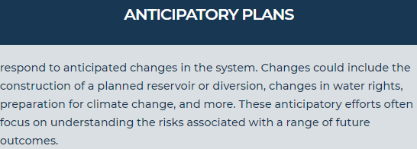
Anticipatory example: Eagle River group looking at climate changes, drought, future trans-basins diversions.

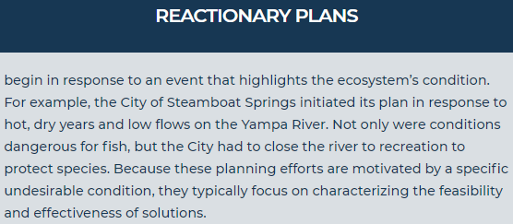
Reactionary example: Crystal River group looking at river segment drying up each year to ensure flows.

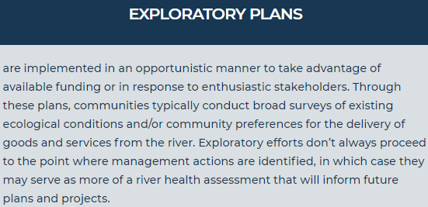
Exploratory example: San Miguel River group assessment to identify issues and find solutions to address them.

- Assessment Planning- or Project-Focused: Group has already identified areas of interest, but larger assessment needed to address longer-term outlook.
- Scope of work easier to accommodate specific projects to outline necessary flows, conditions, funding, etc. Broader or unclear articulation of end goal is more difficult.
- Option to choose immediate project list and long-term project list, along with funding sources, constraints, etc.
- Proactively approach controversy: Address known issues and include controversial topics or projects, but ensure assessment includes all needs/values. Emphasize assessment is not regulation/management, simply offers options that are purely voluntary and incentivized/possibly compensated.
- E & R more problematic during implementation phase rather than assessment, but can be further addressed by coupling multi-beneficial project list and funding opportunities in Phase III
- Lotic Hydrological’s Process (see attached presentation or visit website for more details https://www.coloradomesa.edu/water-center/iwmp_coloradobasin_final_062618.pdf)
1) begin with community survey for values (locations, timing), agency management concerns (areas, goals, challenges)
2) use groups to identify opportunities
3) identify methodologies to analyze existing data sets
4) characterize habitat characteristics to model
5) articulate current conditions and predict future conditions/project options
- Deliverable: list of potential recommendations (i.e. irrigation infrastructure upgrades, rec access, invasive species control, riparian habitat protection, aquatic habitat modification).
- Goal to develop no regret strategies/projects that consider different climate change scenarios to ensure sustainable projects. Incorporate this into RFP (i.e. temp and flow variability) informs what data sets available or what consultants need to capture.
- Questions:
- Group/Community priorities: to understand current conditions or focusing on future options?
- If climate change driving: technical modeling, climate projections from state that projects flows, precipitation in relation to specific areas’ hydrology, geomorphology. Present future issue projections to community/committee to determine if worth investigating project options (i.e. augment flows in specific segments, create storage) and address costs/benefits/consequences.
- Customize assessment for San Juan Basin:
- variables/metrics can be limitless but restrained by budget and time. Examples include hydrology, geomorphology, sediment transport, recreation user surveys/outreach. Quantitative assessment of flows, user days.
- Conducting community/property owner surveys:
- usually via internet, social media, TU chapters, engaging public on river, recreation owners. Difficult to ensure statistically significant population and avoid bias. Using established group and targeted outreach can be extremely helpful with this step.
- Public presentations/acceptance:
- Lotic has developed community framework that reviews how to develop successful joint decision-making and collaborative priorities with non-technical groups. Framework received good response, with matrix of conditions and locations in area of interest, ranked condition of ecosystem or aspect. Easy to understand and facilitates conversations where all parties are on the same page of conditions.
- Cost:
- depends on scope of geographic area, available data, partnerships
- depends on how much local group can do for stakeholder facilitation (survey values, meetings) can be up to 50% of the work. If not a major part of the budget, then lower consultant cost.
- Examples: Steamboat $80,000 tech intensive lasted 1 year, 7 miles of river through town of Steamboat, City of Steamboat, Middle Colorado focused on 75 miles of river + tributaries (2.5-year effort for $200,000 includes 6 contractors w/CPW, USFS, conservation districts), Yampa ($700,000? hydrological models developed), San Miguel focused on headwaters to the Dolores river for around $110,000.
Updates:
- Concept Design Plan:
- Al confirmed formal approval from board for Riverbend to access property
- MSI drawing up contracts with Riverbend, organizing grant matching funds for Concept Design
- Awaiting final grant approval by end of September. Hopefully begin field surveys October or November
- NRCS/SJCD agricultural inventory:
- Application submitted, no approval yet, working on getting details of needs for each ditch. Used WEP as local partner within application. Bring them money from Phase II funding, share data/partnerships/resources/staff to combine ag inventory with enviro, municipal, and recreation assessment.
- Al, Robin, Pat, Justin will conduct field surveys to supplement info needed by NRCS for their Targeted Conservation Program.
- NRCS willing to ask for money for intern to conduct survey work next year, but agency wants specific ditch information in next month before winter. Grad student/intern for field inventory next spring/summer, would need to be approved by NRCS hiring. Celene can help line up contacts with Montana State, CSU, etc. looking for interested students.
Conclusion/Next meeting:
- Working Group to outline Phase II Scope of Work on October 2nd 11 am – 1 pm in West Conference Room at the Ross Aragon Community Center
- RFP vs direct hire: Depending on Steering Committee vote, group can finalize and advertise RFP for consultants to bid on or work directly with Lotic Hydrological to start outlining Scope of Work asap.
- Considerations: expertise/experience with this type of work, other interested companies, local knowledge, community acceptance, price, application and assessment timelines, etc.
- Address geographic scope: Include Upper San Juan & Navajo/Blanco? Only upper portions of the Navajo? Break into phases where Upper San Juan for this phase, move into Navajo/Blanco after established success on San Juan?
- Further define intention of Phase II assessment: combine current conditions work with exploratory (investigate where and what kind of water issues in watersheds) and reactionary (explore specific sites/problem areas) with anticipatory (investigate future conditions/scenarios),
- Align 2 Scopes of Work from beginning (WEP consultant=enviro, rec, municipal + NRCS/SJCD consultant=agricultural): begin outlining what WEP consultant focuses on and what group would need from NRCS/SJCD to ensure other consumptive uses easily integrated into strategies, planning, etc.

