A Guide to Downloading Data from Online Climate Databases
Includes: SNOTEL, USGS, and USHCN
Alpine Hydrology Workshop
March 14, 2015

Learning goals:
- I understand the types and availability of climate data on the Internet, and how to access them.
- I know how to find the closest SNOTEL site to where I live, and use the online graphing tool to compare this years snow depth to the historical median.
- I know how to download daily data from SNOTEL and import it into an Excel document.

Natural Resources Conservation Services (NRCS) SNOTEL
Data: Snow depth, Snow Water Equivalent (SWE), Temperature and Precipitation
http://www.wcc.nrcs.usda.gov/snow/

SNOTEL (SNOpack TELemetry) is an automated system that collects climatic and snowpack related data in the western US and Alaska. The system is primarily used by water managers in the west to create water supply forecasts, and for other resource management purposes associated with the NRCS. This is an excellent real time dataset that climatologists and hydrologists use frequently for climate analysis.

To download data:
- Select Open the Map underneath the map.
- Zoom into southwestern Colorado.
- Click on the site you are interested in when the Colorado state map appears.
  - For the activity today, select Scotch Creek (Station ID: 739).
  - Select Site Page at the bottom of the window that pops up.
- For a quick, easy graph that shows the status of the snowpack compared to the historical median, select Daily Graph in the Snow Water Equivalent row of the Current Water Year column in the Site Reports box.
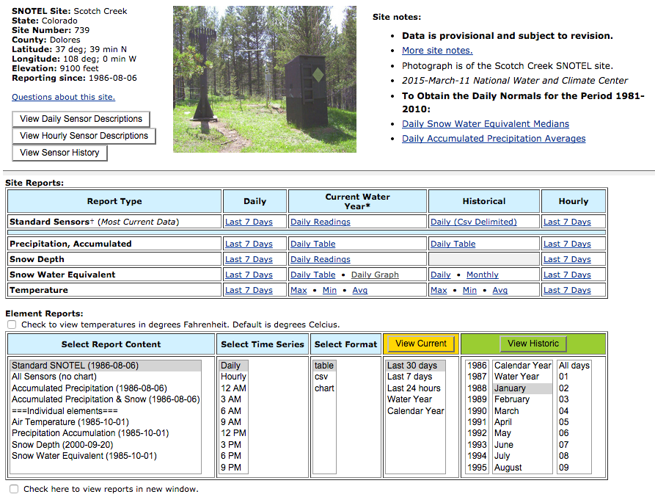

You should get a graph that looks like this:
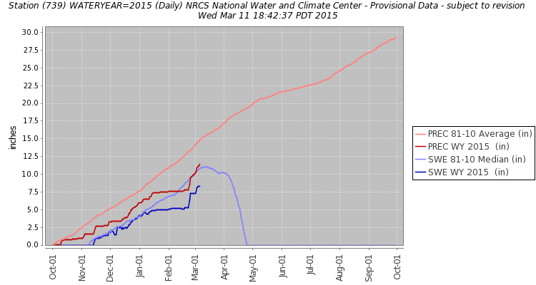
Select Describe headers for a description of the data shown.

Now, to get the raw data in your hands, go back to the Scotch Creek site page.
- In the Element Reports box, select Standard SNOTEL (1979-10-01), Daily, csv, Water Year, 2011, Water Year, All days.
- Select View Historic.

Your screen should look like this:
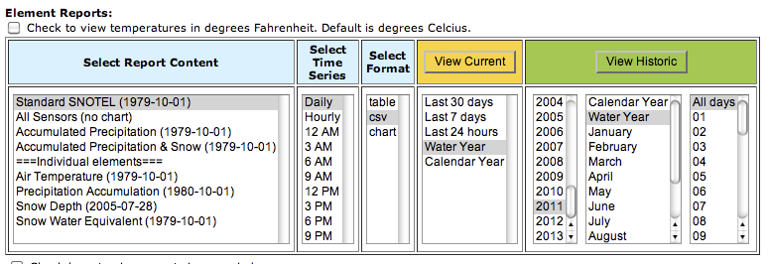
A file will download. Depending on the age/software on your computer, you may or may not need to import the file into Excel. If you click the downloaded file and it opens in Excel, ignore the next section, and save the document as a .xlsx file.

If you click on the file, and it does not open as a document in Excel, follow these steps:
- Open the .csv in Notepad (or the simple word processor on your computer)
- Save the document, include site name, dates, and data type in title (e.g. Scotch Creek_SNOTEL_2011WY.csv) Save as a .csv or a .txt document.
- Open a new Excel document, and click on the Data tab, and the Text (under External Data Sources) icon. Select the .csv document you saved the step before.
- The Text Import Wizard window will pop up. Under Original Data Type select Delimited. Select Next.
- In the next step, select Comma. To check that data is separated into the right columns, scroll down in the window that displays the data. Vertical lines separate the columns. Select Next.
- Select the column with dates in it (e.g. 2010-10-01), it should be highlighted in black. Click the Date tab, and select YMD. This will convert the dates into a more usable format in the excel document (e.g. 10/1/2010). Select Finish, and OK.

You now have a data set ready to go! Save the document in Excel, include the site name, the data source, and date (e.g. ScotchCreek_SNOTEL_2011WY.xlsx) as a .xlsx file.

Now, what does it mean?
Data descriptors:
WTEQ: Snow water equivalent, inches
PREC: Daily precipitation accumulation, inches
TOBS: Observed air temperature, °C
TMAX: Maximum recorded daily air temperature, °C
TMIN: Minimum recorded daily air temperature, °C
TAVG: Average daily air temperature, °C
SNWD: Snow depth, inches

On your own, go through the same steps, and download the data for the 2014 water year.

•••

Included below are instructions for downloading data from other websites. We will not be using them today in the workshop, but these are included as an added resource should you choose to look into them more.
•••

The United States Geological Survey (USGS)
Data: Daily discharge and water quality
http://www.usgs.gov/

The USGS, part of the US Department of the Interior, is a reliable source for impartial information on our ecosystems and environment. The USGS is divided into several core science initiatives; Climate and Land Use Change, Core Science Systems, Ecosystems, Energy and Minerals, Environmental Health, Natural Hazards, Science Quality and Integrity, and Water. Below is a guide to accessing data from USGS stream monitoring sites.

To download data:
- In the left hand column, click on Water
- Under Water Data for the Nation, select Colorado on the “Use a map” menu in the Current Streamflow Conditions box.
- Selecting Colorado should bring you to a page titled National Water Information System: Mapper.
- In the left hand column, click on Surface-Water Sites. Make sure that there is a check in the Active Sites box, but not the Inactive Sites.
- Next, zoom into the area of interest on the map. Zoom into the Boulder area, and find Nederland. Click on the site closest to Nederland, Site Number 06725500, MIDDLE BOULDER CREEK AT NEDERLAND, CO. Select Access Data.

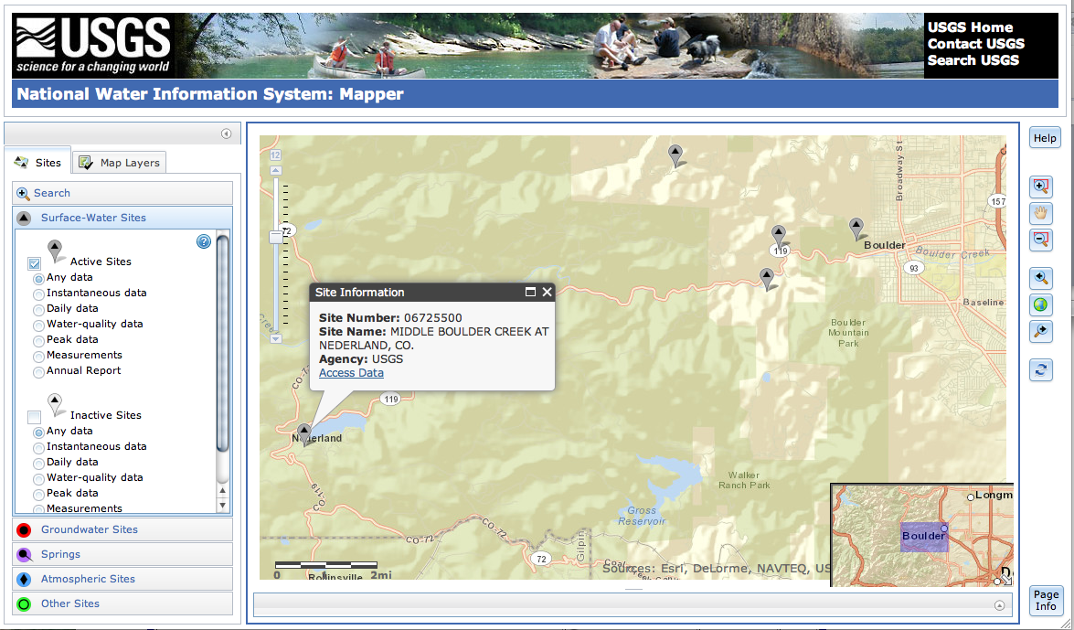

- A new window will pop up with access to all of the available data for that site.

Note: When you select a site, and the window pops up, notice the date range for availability of data (Begin Date and End Date in the AVAILABLE DATA table). Some sites only have 2 years of data available, others have up to 100 years!

- Select Daily Data in the Data Type column of the AVAILABLE DATA table.
- Play with the graph and graph w/stats Output format to see what is available from the site.
- To download data, select the Tab-separated option from the Output format, and enter the period of record you want data for (in this case, 1910-01-01 to 1995-01-01). Note that available period of record is written under Period of Record to the left.
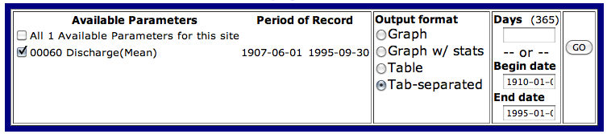
- Select GO.

- A page of text will appear, showing the data. Under the Edit tab, click Select All, and copy (Ctrl C). There is also an option on some computers when you right click to directly export to Excel. You can try this, but also learn how to import tab-delimited data into excel.
- Open a Notepad new document and paste data into it (Ctrl V). Save the document, include site name, dates, and data type in title (e.g. BoulderCreek_discharge_1910_1995.txt). Save as a .txt document.
- Open a new Excel document, and click on the Data tab, and the Text (under External Data Sources) icon. Select the .csv document you saved the step before.
- The Text Import Wizard window will pop up. Under Original Data Type select Delimited. Select Next.
- In the next step, select Tab. To check that data is separated into the right columns, scroll down in the window that displays the data. Vertical lines separate the columns. Select Next.
- Select the column with dates in it (e.g. 2010-10-01), it should be highlighted in black. Click the Date tab, and select YMD. This will convert the dates into a more usable format in the excel document (e.g. 10/1/2010). Select Finish, and OK.

You now have a data set ready to go! Save the document in Excel, include the site name, the data source, and date (e.g. BoulderCreek_USGSDischarge_1910_1995.xlsx) as a .xlsx file.

•••

United States Historical Climatology Network (USHCN)
Data: Daily temperature and precipitation
http://cdiac.ornl.gov/epubs/ndp/ushcn/ushcn.html

The US Historical Climatology Network is an excellent source of high-quality data sets of daily and monthly records of climate observations (daily and monthly temperature, precipitation, wind speed, etc.). The database was developed by the National Oceanic and Atmospheric Administratin’s (NOAA) National Climatic Data Center. There are 1,218 observing stations across the 48 contiguous United States.

To download data:
- Select Web Interface
- A map of the United States is displayed, select Colorado from the drop down list, and click on Map Sites. A list of sites appears, and a cluster of red points on the map. You can zoom in on the map to see a close-up of site locations.
- Select the site you are interested in from the list on the right, and when a pop-up shows up on the map, select Get Daily Data.

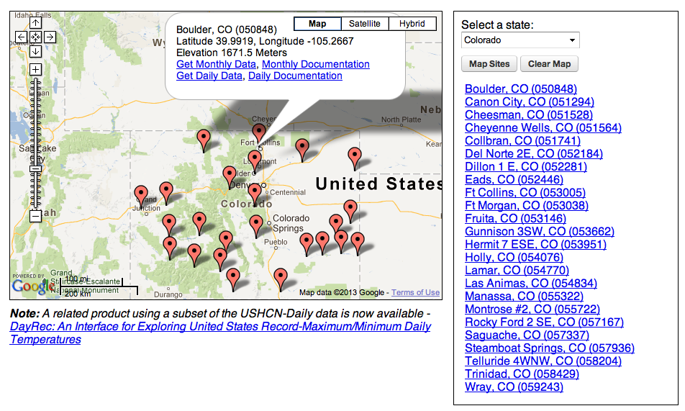

- A new screen appears, with several options for plots and data. Play around with the Available Plots and see what’s available.
- To download data, scroll down to Data Download, and check the boxes under Download a comma-separated file of the data. Select the date ranges you want, and name the output file. Click submit.
- On the next page, click on the link that appears. A pop-up will allow you to save the document as a [.csv]. For importing into Excel, [.csv] will function the same as [.txt]. When you import the data into excel, notice that this is a comma delimited file, rather than a tab-delimited file. In step 2 of the “Text Import Wizard” you will need to check the comma box.
- On newer computers, the data will automatically pop up in Excel, in which case save the data as an excel document.

*Note: With data downloaded from the HCN, there are sometime gaps in data. The dates will not exist in the file, and could switch from 9/2/1987 to 2/6/1988 in one line. Be aware of this!

