Mancos Restoration and Resilience Group
October 1, 2015
Meeting notes
Table of Contents
Mancos Restoration and Resilience Group 1
Homework/Next Steps 2
SESSION I 2
Resilience, Climate and a Changing World – Marcie Bidwell 2
Projecting the future 2
2035 in the 4-Corners 2
Watershed insights 3
Update on the Mancos River and Watershed – Ann Oliver 3
History 3
Reports: 3
Projects: 4
Mesa Verde National Park Science Update – Steve Monroe 5
History of studies on the Mancos in MEVE 5
NPS Southern Colorado Plateau Network – work on the Mancos 5
MEVE – Ideas for Progress – George San Miguel 7
Habitat improvement in MEVE 7
Reclamation in the East Fork, Mancos River - Kirstin Brown 8
Timeline: 8
Issues: 9
Summary – what can be done? 9
Riverine Ecology and the Value of the Mancos to UMU – Tomo Natori 9
Trout Unlimited update – Duncan Rose 10
Update from the USFS Dolores District– Shauna Jensen 10
Session II – Rapid Stream Riparian Assessment 11
RSRA evaluation – Pete Stacey (UNM) and Allison (Wild Utah) 11
RSRA method 11
Documenting Recovery of a Stream/Riparian System at the Jordan River Migratory Bird Reserve – Allison 12
Case study: Functional Condition and Ecological Health of the Santa Fe River in the Santa Fe Municipal Watershed – Pete Stacey 13
Overview of Restoration Thinking and Resilience Planning – Chris Rasmussen 14
Wrap up Conversation and Food For Thought for the Next Meeting 15
Flip chart notes 15
Data/Information Needs 15
Watershed Insights 16

Homework/Next Steps

- Review the list of issues and interests that Paul handed out
  - Is there something missing?
  - What are the top priorities?

- Thoughts on the mission/purpose for this group?

- What does moving forward look like?

- What are our opportunities for funding?

SESSION I

Resilience, Climate and a Changing World – Marcie Bidwell
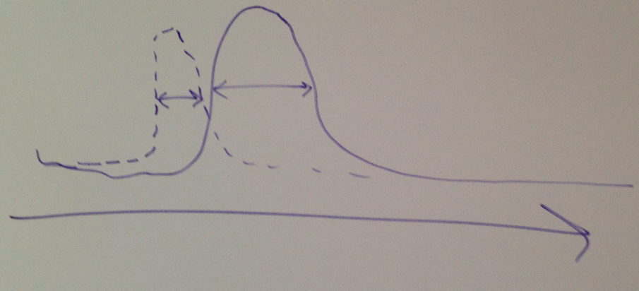
- Change in snow melt---------------------
- Average winter snow line has shifted about 600 ft up in the last thirty years. Important for increases in growing degree days.
- Change in snowmelt correlates to # and frequency of fires.
  - Fire is strongly associated with increased spring and summer temps.

Projecting the future
- RCP 8.5 is where we are today = current “worst case scenario”
- 2035 is the year that the different systems begin to differ drastically, up until then, they follow similar projecteries.
- Climate scenarios
  - Some show it may be dryer, some may be wetter, temperature varies 1-4 degrees.
  - The red dots are the “business as usual” and the blue represent if we curb our emissions
  - 3 scenarios (2035):
    - Hot and Dry
    - Fest and famine
    - Warm and Wet
- 2070: the ‘business as usual’ and the curbed emission scenarios become more apparent
- Adaptation strategies in the warm and wet scenario are more likely to be effective

2035 in the 4-Corners
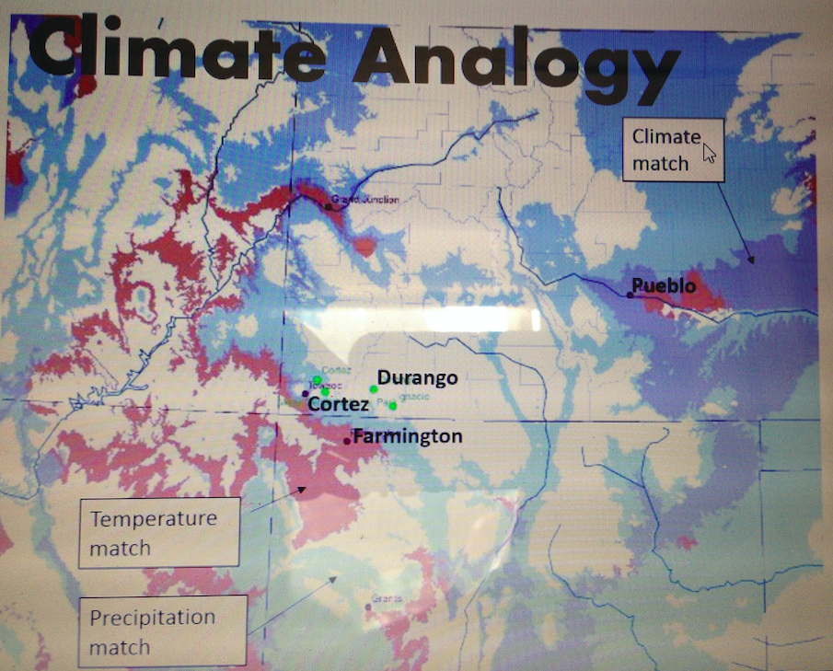
- From the Colorado Natural Heritage Ecosystem Assessment--------------
Climatic envelopes that ecosystem prefer – see slide.
- Slight shifts in precipitation or temperature may be the driving factor for where ecosystems can survive.

We want to plan ahead for the future with a resilience framework, through the lens of climate change

Questions:

Chris R - How do we build in flexibility? Room to maneuver? We might have some good years that build in that flexibility. There may be years where there are upsides to change.

Slides will be available on website: http://www.mountainstudies.org/waterandsnowwork/mancos

Watershed insights
- Steep drainage/sharp transition
- Alpine -> desert all changes to prepare and consider
- Interactions btw mountain to desert
- Snow regime change and how hydro dynamics shift/interact

Update on the Mancos River and Watershed – Ann Oliver

History
Felicity Broennan – convened group and got a number of project going in 2006. She moved in 2009-10 and handed it off to Chester Anderson
He completed the watershed plan funded with 319 dollars
2011 Chester moved and it was passed to Ann Oliver

Ann involved from 2011 to now

Reports:
- Mancos River Basin Instream Report
  - Recommendations from this report:
    - Examine potential for new Instream Flow appropriations
      - Flow protection tool
      - Natural environement to be protected?
      - Water available?
    - Examine potential for instream flow acquisitions
      - Flow restoration tool
      - Someone willing to sell water rights
    - Continue efficiencies projects
    - Consider other projects as appropriate
      - Tamarisk/Russian olive control
      - Stream channel function/health
- Mancos Watershed plan:
  - Priority management measures recommended – see slide

Projects:
- Hoch restoration project (middle Mancos)
  - Development of grazing management plan
  - Installation of instream structures
  - Improving fish passage
  - Improving some diversions
- Beaver diversion
- Willis diversion (in-town down stream of bridge)
  - Headgate improved to close off/adjust water in ditch
  - Allows for fish and sediment passage
- Mancos River Habitat and Diversion Project Phase II
  - To restore aquatic habitat and efficiency of 4 irrigation diversions along 2.4 mile reach downstream of town
  - Habitat improvements
    - Create more pool habitat (Photos, see slides)
  - RSRAs – reassessed a few of the reaches from Pete Stacey
    - 2006: 17 reaches assessed by Dr. Stacey
    - 2011: 3 reaches reassessed
    - 2013: 2 reaches reassessed
    - 2014: 2 reaches reassessed
      - all reassessed reaches except Mesa Verde/Ute border reach (approx. within 0.7) are within 0.5 score of 1st assessment
      - Q: is a 0.5 point within the margin of error? How big of a deal is that change? A: its helpful to look at which indicators score differently, that will give you a fell for the reason that the scores change. let’s ask Pete Stacey.
  - Fisheries data is posted under documents tab on Mancos conservation district website: http://www.montezumaconservationdistricts.org/documents.cfm
  - Water quality data may be on CO data sharing network website, river watch was monitoring but there are not volunteers now
  - Final report submitted in March 2015

Questions?
- Redder ranch reach: didn’t find any macroinvertebrates at the upper end of the reach, but did find some lower
- Webber reach did have full suite of macroinvertebrates.
  - Jack: Water quality at that confluence got diluted sufficiently so that the invertebrates went of dramatically after.
- We need river watch volunteers

Mesa Verde National Park Science Update – Steve Monroe

History of studies on the Mancos in MEVE

2015 - Brandon – working on mapping effort to map whole channel of Mancos in MEVE
2010 – pilot study of the ecological effects of mercury deposition in Mesa Verde – mercury in songbrids, inverts, fish and crawfish
2007 – cobble embeddedness study
2006 – vegetation mapping on aerial photos
2001 - fish survey
2006 and 2012 – RSRA one site in park
1997-1999 – Riparian Plant Recovery Monitoring
1990s - fish shocking studies done by USFW
1998 - ? – T walk Surveys, biological and physical surveys at 33 transects
1987 – Cottonwood survey
1980-2000 – Water quality samples collected once per year
1978, 1990, 2005 – Pool surveys
1935 – Stream survey

Other activities:

1998 - Cattle removed from river corridor, tamarisk removal
1999 – biological control of Musk thistle
2004 – present – Russian Knapweed assessment
2005 – Cheat grass treatment

NPS Southern Colorado Plateau Network – work on the Mancos

- 4 projects, 3 on river and 1 on springs
- sample water quality from the mancos since 2005
  - sample for: nutrients, metals, bacteria, cations, anions
  - partnered with EPA on ‘contaminants that are emerging concerns’
  - exceeding in arsenic and sulfate, also high levels of ecoli and total coliforms
- Collecting Macroinvertebrate samples
  - Low in species richness and diversity, pretty poor condition
  - Attributed to channel substrate: highly imbedded
- Qualitative habitat sampling
- Physical habitat measures
- Integrated riparian monitoring
  - Different from RSRA

Mancos River near Anitas Flats:
- Water temperature: Daily highs are exceeding daily average
- Alluvial groundwater (only one year of data so far)
  - Groundwater is only about a meter below the surface – see slide
  - Connectivity b/w ground and stream water

Stream flow gages
- Present:
  - Jackson Gulch Reservoir Inlet canal (JACUPPCO, JACCANCO)
  - West Mancos River below Jackson (MANJACCO)
  - Mancos river near mancos (MANMANCO)
  - Mancos river at Anitas Flats
  - Mancos River near Towaoc – longest running gage (09371000)
- Closed
  - See slides
- It would be valuable to pull data together from all the stream gages.

NPS Inventory and Monitoring Program
- 2005-2006 and 2010- Present
  - Water Quality monitoring (1 site near north boundary, Anitas Flats, USGS gauging station): nutrients, trace metals, bacteria, major cations and contaminents and emergent concerns (pesticides, waste water, organic compounds, fire retardants)
  - Typically meets water quality standards. They are seeing arsenic and sulphates at higher levels. In the East Mancos, see increases in ecoli and trace metals.
- 2005- Present- Aquatic macroinvertebrate monitoring
  - The bug population is in pretty poor condition in species richness and diversity. We generally attribute that to channel substrate (highly embedded and high level of fine sediments). May be attributed to the Bircher Fire, we have seen downcutting and erosion on roads in the reach and the area has not revegetated. It’s a Mancos shale soil, so that may be a natural contributor).
- 2014 Integrated Riparian Monitoring (Surface and Groundwater hydrology, Fluvial geomorphology, Riparian Vegetation)- 5 year monitoring cycle.
  - The strategy is to look at 500 meter reach, total station, channel morphology to be repeatable over time, look at hydrology (groundwater, surface water, interactions, plant communities). May expand the number of sites, or focus reach to include other sites.
  - Observations 2014-2015
    - Surface Water Daily maximum and minimum temperatures- daily high temps regularly (annually) exceed the Colorado Acute and Chronic Standards for aquatic life.
    - Groundwater is only 1 meter below the surface, at the floodplain level. There is a direct and immediate response to stream and groundwater connections. The connectivity is important to the riparian vegetation. This is not always the case in other places, such as Chaco River. This is only one transect at one point in the river, and may not be true for all areas.
- Stream Flow- Mesa Verde uses the Anita Flats USGS gauge (near the northern park boundary).
  - There are 11 gauges that Steve was aware existed.
    - 09370600- Mancos River at Anita Flat below Mancos- 2003 to present
    - 09371000- Mancos River near Towaoc- 1921 to present
  - Currently, the river goes almost dry every summer.

MEVE – Ideas for Progress – George San Miguel

Habitat improvement in MEVE
- Exclude livestock grazing
- Tamarisk and Russian Olive removal in the 90s
- Primary invasive plant control presently on Russian Knapweed – chemically
- Canada thistle – rust, a natural bio control may become available
- Not sure how long it will take to get new cohorts of cottonwoods
  - Natural riparian gallery
- Mancos River Stream Gage – since 1995
  - Park not likely to keep funding it
  - Provides real time data
  - USGS website – real time stream flow : http://waterdata.usgs.gov/co/nwis/current/?type=flow&group_key=huc_cd
- Fire exclusion
  - Burn in small pieces
- Faunal species of concern
  - Near lack of non-native fishes – big benefit, important to keep out
    - Solid diversion on UMU
  - Historically pike minnow and razor back sucker were in the Park, not a valid goal to restore these in the Mancos River in MEVE
  - NM jumping mouse – never been surveyed for
  - For the time being efforts concentrated on:
    - Round tailed chub, flannel mouth suckers and ?
  - High elevation lanceleaf cottonwood and low elevation rio grande cottonwood
    - In the lens of climate change, low elevation cottonwood may sustain longer
  - Where are the locations where cottonwoods used to be and not anymore
    - Identify places where we would want to plant cottonwoods, where would they be most successful?
  - SW Willow Flycatcher – historically had them
  - Northern Leopard frog – historically common, none now
    - UMU got them for the first time in ten years at springs
  - Possibility to restore beavers
  - Riparian woodland – may conflict with beaver, what is the right timing for both?

Summary:
In order to sustain these historic species, there would need to be manipulation of the river. Build in resiliency. What is the real potential? Is it unlikely to have a continuous stand of cottonwoods? The more it is restored, the more resilient it will be for the effects of climate change.

Questions/comments:
Q: are cottonwoods the restoration tree of choice still? A: yes, perhaps box elders

Comment: Chris R: Requirements for specific genomes of cottonwoods, if we planted locally adapted cottonwoods now, in a short time period they would not be able to persist. Plant for the projected degree change in temperature. What species can persist the largest temp changes? If your locally adapted stock can’t persist in the future then maybe that is not the stock to plant. Lets pick something now that can hold in the future.

Comment: Tomo: Mark the hybrid zone of cottonwood trees on the river. I think they are not so locally adapted. I don’t think the genetic specificity is a huge factor. We should experiment and not be afraid of mixing the different groups of plants from the same drainage. Lets see how resilient they are.

Reclamation in the East Fork, Mancos River - Kirstin Brown

East Mancos River

Issues: 303 listed for copper impairments
Not a lot of fish in there

Timeline:
- Red Arrow mine (started 1930) and Gold Dollar mine located in mid reach of East Mancos
- 1986 - Gold Dollar mine blew out –anecdotal reports of large scale fish kill
- 1969 – trout noted near the White Rocks (halfway)
- 1975 – no fish
- 1988 – USFS finds habitat not suitable for fish at White Rocks, copper coating stream bottom
- 2000 – Colorado Geological Survey – naturally degraded surface waters
- 2005 – health department released hazardous materials report
  - most of poor water quality coming from headwaters
  - high copper values coming out of headwaters (rush basin), but no major mining activity
- 2009: worked with Felicity to sample near Gold Dollar mine, associated with Gold Dollar mine spill, but caught the Red Arrow too.

Issues:
- No data from aluminum (timeline?), but the white precipitate is visible
- Rocks coated with orange – iron - in Rush Basin
- Spill of unknown quantity of poor water quality and sediment from Gold Dollar
  - Sediment from spill has been washed away with high flows
  - Gold dollar unlikely to blow out again
- East Mancos continues to have poor water quality near those two mines
- All tributaries in this area have better water quality than the East Mancos
- Red Arrow does not discharge into the East Mancos. No mine drainage. Was in compliance with EPA, CDPHE, CDRMS, but not anymore.
  - Currently digging pond out to get ready for next storm cycle
- low flow water quality problems:
  - copper, zinc, cadmium and aluminum
  - pH ranges from 4.5 – 4.7 (goes up as you move downstream)
  - pH of tributaries is around 7
- dissolved aluminum is extremely high
  - White precipitate is located both above and below both mines, moves around depending on pH of water.
  - pH of water determines when metals will precipitate out
- Arsenic in the sediment is extremely high, 7000!

River watch sampling 2007
Aluminum peaked in June, Arsenic peaked in July – may be due to arsenic coming from higher in the watershed, held in snow for longer than aluminum

Summary – what can be done?
- Reclamation options are hard, it is remote and inaccessible.
- Pyrite scattered on the hills “blanket of pyrite”
- There is a waste pile in a wetland that does have water in contact with it, but no mine drainage from the mines.
- Perhaps something can be done with the Thunder Mine
  - Studies would have to be done to ascertain if Thunder is an impairment.
Biggest problem areas through the lens of climate change:
- Forest fire would mobilize more sediment – problem
- Low flows year round would be a problem – more heavy metals
- Violent storms could wash waste rock piles into the river

Riverine Ecology and the Value of the Mancos to UMU – Tomo Natori

Wetland below the confluence – cattails present
Wetland is fenced
Currently removing tamarisk
No bugs this year – may be from a scouring flash flood
Conduct tamarisk beetle survey
Sand bar – fresh deposit
Insect damage
Mulch tamarick with a machine - easy to decompose tamarisk
Native plants found to be growing in the tamarisk
Introducing 50 species
Post fire sediments deposited in riverneed to keep measuring water quality and quantity
Diversion on Mancos highway to be improved/removed?

Trout Unlimited update – Duncan Rhose(spelling?)

CAMP – C… Adaptive Management Plan
- Limiting factors moving forward
- Ecological niche = mountain streams, habitat = trout habitat
- Developed state of the science for each factors and threshold associated with each factor and then mapped them. Identified where the strongholds are.
- Currently in the process of integrating.

Limiting factors identified:
- temperature
- pollutants
- flow regime
- segment linked, connectivity and barriers
- fish competition
- sedimentation
- salmonid disease

TU report on MSI website, Mancos page: http://www.mountainstudies.org/waterandsnowwork/mancos

Update from the USFS Dolores District– Shauna Jensen
(read by Paul Morey)

- 2016 – North Mancos Grazing EA
  - results of studies will be a ways off
  - trend studies
    - vegetation
    - Proper Functioning Condition (PFC)
    - Rangeland health assessment
- ~2005 – West Mancos Grazing EA
  - similar studies as above
    - but also park compaction around Transfer
    - freeze-thaw broke up compactionof livestock use
- 2008 – Sudden Aspen Decline (SAD) study
  - study with Fort Lewis
    - examined rodent and bird density, diversity and disease
- 2000 – Ponderosa Health
  - Bill Romns

Session II – Rapid Stream Riparian Assessment

RSRA evaluation – Pete Stacey (UNM) and Allison (Wild Utah)

RSRA method
- considers various components of overall system
  - water quality – non chemical
  - hydrology geomorphology
  - fish/aquatic
  - riparian vegetation
  - ?
- addresses the ability of the ecosystem to provide various desired functions
- objective and repeatable
- provides guidance for future restoration
- metric/standard to compare system to: how the system would be functioning if it had not been impacted by human activities
- Desired to use reference reaches, but there were none
  - Instead used science to understand how the particular system would function
- 3 people, 1 assessment = ½ day (when trained)
- Scores: 5 pt scoring system
  - 1 = completely non-functional
  - 5 = fully functional
  - very specific definitions for each scoring level
  - 1-2.5 = immediate remedial action
  - 2.5-3.5 = functioning at risk
  - 3.5 to 5 = functioning

Wanted to get a picture of where the Mancos was coming into the valley and where it exited the agricultural system.

Results of these assessments:
Functionality is trend based
- Algal growth - the more algae = the more nutrients
  - Coming into the valley there is very little nutrient loading, drops through town and goes high again through the rest of the system – issue in terms of restoration
  - This may be the reason there is no trout here
- Temperature loading from lack of shading
  - Low channel shading = increased solar heat – changes from cold water fishery to warm water fishery
- Non chemical water quality
  - Steady decline moving downstream
- Positive results
  - Water quality generally good upon entering Mancos Valley
  - Bank stability generally good
  - Riparian soil good
  - Macroinverts good until Mancos Canyon due to fires the year before
  - Grass and forbs is healthy in many areas
- Areas of concern
  - Cobble embeddedness increases as it moves downstream
  - Deer browsing is heavy
- Stream Channel Geomorphology
  - Not great
- Stream floodplain connectivity
  - Score of 1 – very bad
- Fish habitat
  - Remains pretty high until lower reaches
- Riparian vegetation
  - Generally good upstream, drops and then rises again after the canyon
- Wildlife habitat – good but variable
- Conclusions
  - See slides

RSRA does not work on ephemeral systems
Most of where we work are warm water fisheries now but they weren’t originally

Documenting Recovery of a Stream/Riparian System at the Jordan River Migratory Bird Reserve – Allison

- 130 acres of riparian habitat in the Jordan floodplain – Great Salt Lake Audobon restoring the area
- rerouted a tributary to make it go through the reserve.
  - after they did it, development boomed, which put significantly more storm water into the system
- Allison did an RSRA survey in 2011
- 2015 re-survey: http://www.wildutahproject.org/programs/riparian/RSRA
- 2013 a new manager introduced beavers
  - according to reserve manager, beavers are “mining” the silt out and are pushing the silt downstream
  - flooding out their own dams
  - Channel is now waist deep, previously was not that deep anywhere (in 2011)
  - Beavers are cutting down cattails to keep their channels open
- Comparison of 2011 survey – 2015 re-survey after introduction of beavers
  - 2011 – couldn’t see algal growth (water to turbid), 2015 algal growth = 4 (good)
  - channel shading got better in 2015 due to increase in willows
  - floodplain connectivity, vertical bank stability and hydraulic habitat diversity was better in 2015 than in 2011
  - underbank cover increased a lot in 2015 (14% - 50%)

Laser + PVC pipe to conduct stream cross section. Ratio to predict overbank flooding
Each indicator is backed by science in the users guide

Case study: Functional Condition and Ecological Health of the Santa Fe River in the Santa Fe Municipal Watershed – Pete Stacey

Work in the Santa Fe watershed illustrates how to use RSRA.
SF watershed is a culinary watershed, catastrophic fires are a big deal there.

SF River - Heavily used for the last 400 years
- PNM bought it and closed the watershed to people in the 30s
- 2 reservoirs built in the 30s and 40s
- unimpacted system for the last 80 years
- overall reach score was a 4 – good, but is that actually true? Targeted spatial analysis shows where the problems areas are
  - Its not
  - There is no overbank flooding, it’s a ditch essentially
  - Riffle and pool abundance dropped between dams
    - Created by high flows, but between dams there are no high flows
  - Underbank cover for fish was really bad
    - Due to controlled flows and lack of overbank flooding
  - Macroinvetebrate diversity is good
- Regulated/controlled flows and no overbank flooding made many of the individual indicators very bad.
- Reaches above the reservoir are very good
- Exceptions are primariliy related to original removal of most vegetation leading to channel entrenchment and past large flood events
- The reaches between reservoirs is good except for specific problems (above)
  - Targeted special analysis identifies where the problems are and where they originate
- What restoration mechanism would allow us to alter these variables?
  - Used digger logs
    - Put in at an angle to create a sort of spill way for high flows
    - Exact duplicate of what nature does itself “anti-engineering”
    - They force things to the side instead of the center like V-weirs
  - Four clusters: block flow, make contact with bottom, creates riffle and pool system
    - Manufacturing one of the component that was missing from the system
    - They don’t wash out: 30 CFS came through system this year, normally 6 CFS and they didn’t wash out
    - Not only changing quality of fish habitat but is affecting the floodplain
  - Drilled wells near digger logs
    - Previous to digger logs ground water followed stream flow
    - Wells next to digger logs show that the digger logs are buffering the system
      - The roots of riparian plants never get below the water table
Use RSRA to figure out where you have problems in your system and then you look to see if you have ways to counter act those. That’s how you create a resilient system

Questions/comments:

Q: Can we use RSRAs in a variety of systems? A: it’s a health check up, nothing in there that will tell you how to fix it. The RSRA will tell you where there is potential for restoration and the suite of characters that need to be addressed. The alternative approach is a top down approach, decide on a method and use it everywhere. This is a bottom up method to find out where/what the issue is. It guides you to what actions to take. You pick the individual restoration method. To restore functionality in a system, you need to know what is not functioning.

Comment: Ann O. - The challenge is not the restoration itself, but the management goals of what you are working with. This [SF digger logs example] is a useful example of a restoring to a resilient system.

Comment: Duncan R- Tipping point thresholds where you reach the point where the habitat disappears. Where are these likely to occur? At some point there is a magnitude when a system simply cant function any longer.

Do you think we need to do more RSRAs on the Mancos River?
Do it in concert with a restoration action
Ann: we did a re-survey of a site you had done before we did any restoration work. There hasn’t been a survey done since, that might be useful knowledge.

Overview of Restoration Thinking and Resilience Planning – Chris Rasmussen

The world we have lived in has been the restoration world, now the conversation has turned to resilience.
Reconciliation ecology – a recognition that the systems are so heavily managed and fundamentally changed that we can only maintain pockets of what one was

There is a shift in thinking
- Protect, reconnect, restore, sustain (TU)
- Instead of restore, promote resilience: Protect, reconnect, promote resilience
- There may be places where reconciliation is the only option, but where are the places that we can build in resilience?
- Build resilience into our water use system

Upsides: We have a lot of data for some reaches and some facets
We are having to deliberately make choices now, rather than not make choices that still have effects
Identify stream reaches that are sturdy and those that are fragile where a little regime change may cause it to fall apart
Think about means while we plan for extremes
In the reaches that are already strong, how do we keep them strong?
Think about function and be explicit about the why, what and where
Observe and mimic in order to exceed

Wrap up Conversation and Food For Thought for the Next Meeting

Is functional condition equal to resiliency?

Maintaining the integrity of the whole system could possibly be the most resilient thing we can do.

We have been dealing with systems that are so non-functional that we think they are fragile. That may not be the case. The system has the ability to handle extreme stress. Beavers are successful because they maintain their environment regardless of what is happening.

Demonstration projects now for future funding.

MCD – everything happens by committee. Once this group gets their feet on the group with a direction, come to the board meeting and give us an encouraging speech with how we can participate. We have communicated well with land owners before and that is a major part of the river.

Flip chart notes

Data/Information Needs
- Water quality analysis throughout drainage
  - Riverwatch volunteers
- What is the history of the diversions?
- Summarize information from all water gauges (current and historical)
- What is the minimum water flow for fish (warm and coldwater)?
- Can beavers negatively impact restoration efforts?
- What cottonwood trees will be adapted for our future climate?
- How much aluminum is in the East Mancos?
- Conduct RSRA surveys in problem areas in the drainage
- Conduct RSRA surveys pre and post projects

Watershed Insights
- Steep drainage, sharp transition
- Alpine to desert – all changes to prepare and consider
- Interactions between mountain and desert
- Snow regime change and how hydro dynamics shift and interact
- Infrastructure resilience and system design

