**Upper San Juan Watershed Enhancement Partnership (WEP)**

**Stakeholder Feedback & Questions**

**Compiled Phase II Feedback and Questions:**

(Note, contact names have been removed for privacy, but if stakeholders provided this information, it was shared with WEP steering committee members and partners)

**New individuals/groups interested in WEP**

* Contact: *removed
* Background: Involved with San Juan Forest Health Partnership, Weminuche Audubon, and Lower Blanco Property Owners Association
* Suggested resources/contacts:
  + - Weminuche Audubon [weminuche.audubon@gmail.com](mailto:weminuche.audubon@gmail.com)
    - Dr. Ross <https://msb.unm.edu/divisions/fishes/people/stephen-ross.html>

“Dr Steven Ross is a noted evolutionary biologist who is an expert on fishes of NA. He is a part-time resident of the lower Blanco community, also involved in Blanco River Restoration Project. Website from UNM Museum of Southwestern Biology”

* Blanco River Restoration Project (10th anniversary): Serve as an example of local river restoration work. “Involved many of the citizens in the lower Blanco community acquiring several hundred thousand dollars for river restoration work. There is also an historical ditch system in the valley that several citizens are trying to rejuvenate.”
* Areas/Values of Interest: Forest health, beavers
* Contact: *removed
* Background: local teacher, BS in watershed science, past work in Forest Service, sediment transport study, water quality, wildland hydrology, river restoration monitoring.
* Areas/Values of Interest:
* Fireflies in Pagosa Springs area (<https://www.southsanjuans.info/post/fireflies-in-pagosa>. Interesting in raising awareness of species and protect habitat near wetlands.
* Hatcher water supply reservoir
* Issues: “shallow, has water rights that our out of sync with demand, both of which impact the water quality in the last summer and fall.  Compounding the issue is the higher than necessary sediment loads in the drinking watershed.  There are at least 2 dozen active headcuts advancing above the reservoir, which deliver sediment to the lake decreasing its lifespan and water quality.  A steep section of Piedra Road also delivers magnesium chloride-laden sediment into a drainage upstream of the lake.  Lastly, there are limited BMPs taken during new construction adjacent to lake drainages.”
* Suggestions: “fixing the headcuts and constructing a sediment detention pond for the Piedra Road sediment to the Forest Service” (Photos of 5 different headcuts)

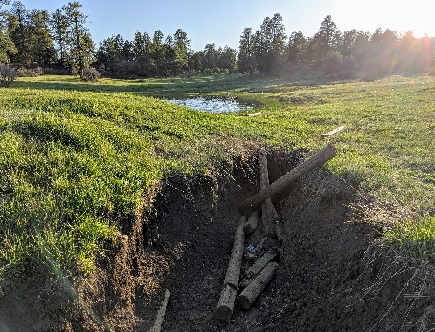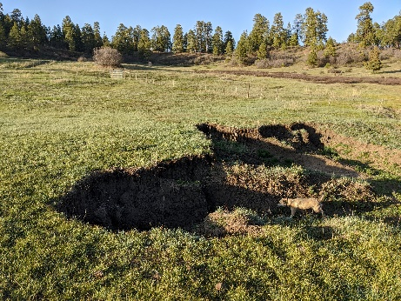

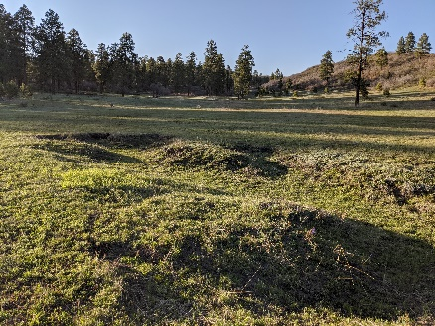

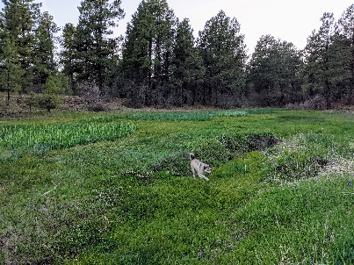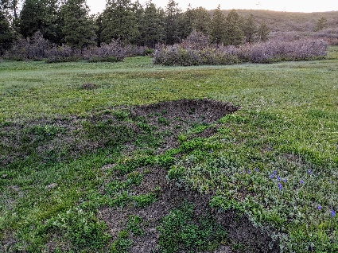

Pagosa Wetland Partners:

* Contacts: *removed
* Background Info: volunteers with a citizen-led advocacy group” named the Pagosa Wetland Partners.
* associated with the National Audubon local chapter Weminuche Audubon in Archuleta County.
* “formed as a group a year ago in response to potential residential development along the San Juan River in downtown Pagosa Springs within the 15 remaining acres of The Springs Resort. Our intent is not to be confrontational, but rather to assist the community by utilizing the best available science to produce the best possible outcomes. Land use development codes are not always sufficient to prevent problems.  We feel it is important to address potential impacts to the wetlands as well as to the complex hydrology of this section of the San Juan River.”
* Area of Interest: “potential *development in The Springs Resort, directly adjacent to a riparian wetland ecosystem* with unique native plants and flowing water habitat that is utilized by 155 bird species (last count 2019) and companion animal communities. This wetland has a highly unusual feature of warm spring water inflow creating marsh and ponds that stay open all winter. It is an important refuge for migrating and overwintering birds.  This entire system is within and connected to the Upper San Juan River and its riparian corridor.”
* Values: protect wetlands at risk from development impacts. This unique riparian zone is also highly valued by the community for recreation, education, ecotourism, birding, and the central role it plays in the quality of life enjoyed by citizens and visitors alike. We are also aware that when it comes to avoiding, or mitigating, environmental impacts from inappropriate land uses, an ounce of prevention is worth a ton of remediation.
* Involvement with WEP efforts: “We enthusiastically support your efforts and are excited to help in any way we can. Our intent is to be a source of information and education for our community, and in turn to be able to provide you with useful feedback and information you can utilize as the San Juan Watershed Project proceeds.” Reports & references provided.

**March 2021 Public Meeting Stakeholder Questions:**

Due to the volume and partner capacity to compile and address specific stakeholder questions related to Phase II tasks and presentations, the WEP did not publish every question sent to steering committee members or partners. Rest assured, these questions were answered to the WEP’s best ability and as quickly as possible. Example of questions directed to WEP and answers (Q & A) are provided below.

* **Q:** Lotic mentioned, for example, that the period between 1990 and 2020 showed a 700 AF decline in the San Juan River annual flows.  Can you tell explain what the total flows are in acre feet (AF) to judge the importance of a 700 AF decline? Were the decades between 1990 and 2020 used for an assessments and modeling an anomaly? For example, we know that 2000-2020 was relatively dry. Was 1990-2000 relatively wet?
* **A:** The average annual yield for the San Juan at Pagosa observed over the 1990-2020 period is approximately 256,500 acre feet. The average summertime (Jul-Sep) yield for the San Juan at Pagosa observed over the 1990-2020 period is approximately 38,635 acre feet. Values at the beginning of the series tend to be higher and values at the end of the series tend to be lower. The downward trend observed in the 1990-2020 data indicates an average year-over-year reduction of approximately 700 acre feet per year. Joe Crabb noted that this volume is slightly more than the storage of Lake Forest. All of these numbers should be treated as *provisional*. The interpretation of these numbers is nuanced and must be viewed in context of the trends observed in other flow behaviors and with careful consideration of some of the large flow events that occurred in the early 1990s. Please take note there will be some extra discussion about the sensitivity of the trends analysis approach to the selected time period and a set of final numbers presented in the final report.
* **Q**: How would I double-check these numbers and calculations? Is there a public data source used for modeling?
* **A:** All of the historical daily streamflow data for the San Juan at Pagosa came from the USGS gauge (<https://waterdata.usgs.gov/nwis/uv?09342500>)

and it is all publicly available. Lotic writes computer code to do all of the statistical and trends analysis on the data. Data tables and graphs of this information are provided in Lotic’s report, found in Appendix B of our Phase II CWCB Final Report at <http://www.mountainstudies.org/sanjuan/smp>.