Calculating the Amount of Water in a Snowpack
Alpine Hydrology Workshop
March 14, 2015

Learning Goals:
- I can calculate the Snow water equivalent (SWE), given snow pack data collected on a pit sheet.
- I can describe environmental factors that influence spatial variability of snow depth and density.
- I understand basic interpolation techniques needed to estimate snowpack qualities over larger scales.
- I can estimate the amount of snow water stored in a basin, and comment on its importance for local water resources.

Background:

Snow pits are an important data collection tool for gaining insight into a mountain snowpack. Since the snow’s characteristics vary across the depth of a snowpack, it is important to dig from the snow surface all the way to the ground to understand how the snow changes. In deep snow packs this is hard work, but well worth the effort! Information gathered from digging a snow pit is used to:

- Estimate the snow water equivalence (SWE) of the snow, or the amount of water contained within a snowpack. SWE is calculated based on the depth and density of snow. This is critical information to understand how much water is stored in the mountain snowpack and how much will be available to downstream users as the snow melts throughout the summer.
- Identify stratigraphy of the snow pack. Stratigraphy refers to the different layers that form throughout the full depth of the snow. Stratigraphy is very important for determining snow pack stability and avalanche hazards. There are also some ecological implications of the snow-layering present within a snow pack.
- Understand the stage of snow metamorphism, or the way that a snowflake changes size and shape, which has implications for albedo and snow stability.
- Snow pits provide field measurements that we take as being “correct” data. These data points are used both to build and to calibrate computerized snow models.

However, snow is spatially heterogeneous. This means that the snow depth and density in one location is often very different than in another location, even if the two locations are close together.

1. Interpolating Snow Characteristics Across Mountains Worksheet

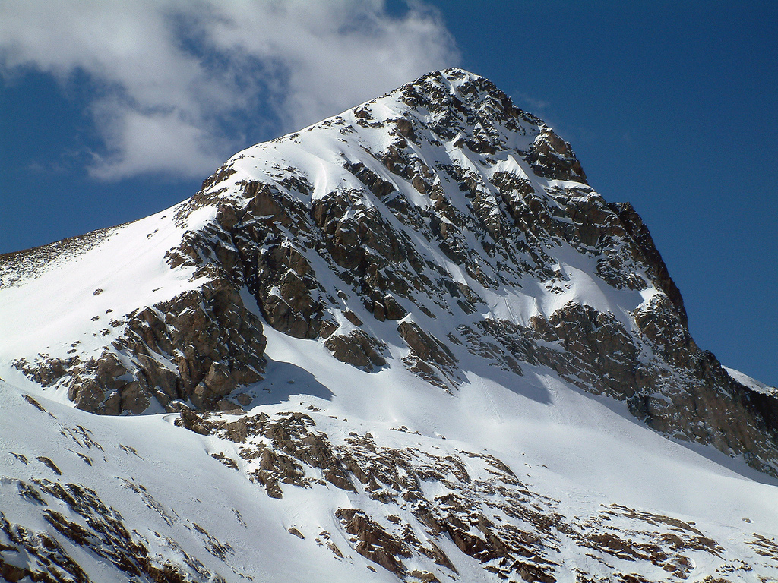
Photo credit: NSIDC

Part A) Snow depth is most highly affected by what three environmental factors?

- ____________________________________

- ____________________________________

- ____________________________________

Part B) We can interpolate a snow surface using known data points (usually from snow pits or snow depth probe measurements) to inform snow depth and density at nearby locations.

Commonly used interpolation methods include:

2. Calculating Snow Water Equivalence (SWE) at a Point

Data from a snow pit is recorded on a “pit sheet.” An example pit sheet is below. The pit sheet information used for calculating SWE are found in the columns second and third from the left:

- “Net weight (g)” is the mass of the snow collected in a 1 liter snow sample. Thus, the value found in this column is g/L (which conveniently converts to kg/m3) and is the density of the snow.

- “Height above ground (cm)” is the measured height for each interval where density was measured. Thus this is the height of the top and bottom of the snow layer. Notice the top of one layer is the bottom of the layer above it. To find the depth of each layer, simply subtract the two heights. Most of the layers are 10cm high.

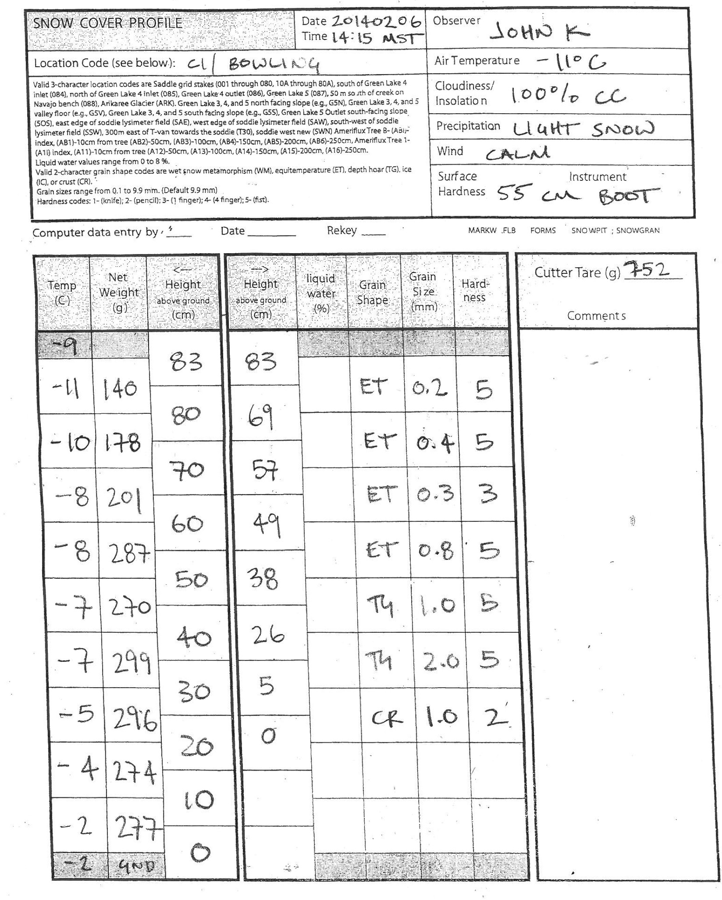

Snow density changes over the depth of a snowpack. In order to capture the different densities (and thus the different water contents) of varying layers throughout the snowpack, snow density measurements are made every 10 centimeters from the snow surface to the ground. The density at each 10 cm interval is recorded and used to calculate the SWE for that layer. By understanding density changes within the snow pack, we can more accurately calculate SWE.

$$SWE=\left(snow depth\right)* \frac{snow density}{liquid water density}$$

Liquid water density is a constant equal to 1000 kg/m³.
The total estimated SWE for the snowpack is the sum of all the layers.

Example calculation:

Calculate the SWE for a layer that has a density of 450 g/L.

$SWE=\left(snow depth\right)* \frac{snow density}{liquid water density}$ = $\left(10cm\right)* \frac{450 \frac{kg}{m3}}{1000 \frac{kg}{m3}}=4.5 cm of liquid water$

Attention! Carefully examine the pit sheet. You’ll notice that not every layer is 10cm high. For instance, the surface layer is 83cm-80cm = 3cm. By using the above equation for each layer, you can accommodate the different layer heights in the snow pit. Again, the total estimated SWE for the snowpack is the sum of all the layers.

NOW CALCULATE THE SWE FOR THE SNOWPACK REPRESENTED ON THE PITSHEET.

3. Estimating basin scale snow water resources

The SWE you just calculated represents the “height” of liquid water over the depth of the snowpack at a single point. We can apply this SWE value over an area of snow to get the volume of water stored in the snow pack.

How much water is stored in Senator Beck basin??

- The area of Senator Beck basin above snow line at maximum snow accumulation is 290 hectares. Of this area above snow line, assume 92% is snow covered (this accommodates rocky buttresses, snow scoured areas, etc).
- Take the SWE calculated from the pit sheet to be the average SWE in the basin. (Disclaimer: everything we learned in part 1!)
- 1 hectare = 10,000m²

The average American uses 80 gallons of water per day. With the amount of water stored in Senator Beck basin at maximum snow accumulation, how many Americans can be supplied by the water in Senator Beck basin for 30 days? (264 gallons = 1m³)

