Background and Introductory Material

The completion of the WEP planning effort will yield a list of projects, processes, and management actions that enjoy a broad base of community support, exhibit limited legal/political/administrative constraints, have identifiable champions for implementation, and present logical funding sources. Ultimately, a compilation of a set of locally-defined and prioritized projects will increase the likelihood that any one of those projects, processes, or management actions receives financial assistance from the State of Colorado under a variety of granting programs or other funding mechanisms set up to support the state's water management priorities. Funding support from the state, in turn, greatly increases the chance that any local project can be fully implemented.

Please take the time to review the Phase II assessment summary information presented here and reflect on the cutsheets attached prior to the public workshop. The Strategies and Actions articulated in the cutsheets respond to Areas of Concerns and Needs falling into the four categories presented in the graphic below:

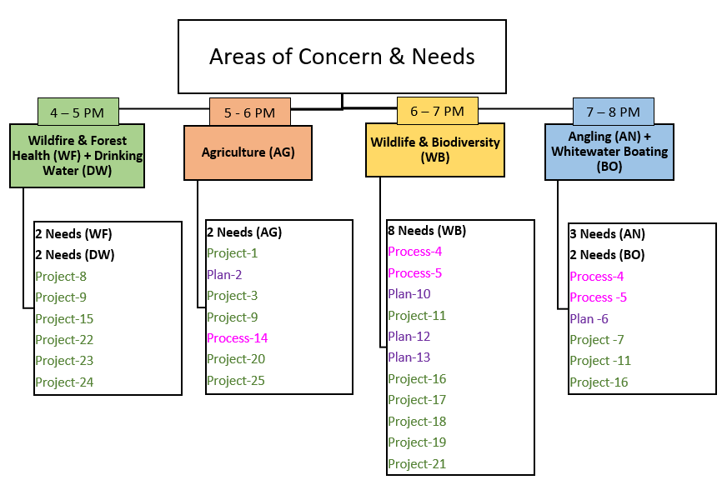

Individual Session Agendas

Separate workshop sessions will be hosted for each Area of Concern. Workshops will be hosted on April 7th as follows:

- Wildfire & Forest Health + Drinking Water session (4-5 pm)
- Agriculture (5-6 pm)
- Wildlife & Biodiversity (6-7 pm)
- Angling + Whitewater Boating (7-8 pm)

Each workshop session will consist of the following activities:

- Review of the Needs identified in Phase II corresponding to the relevant Area of Concern (10 min)
- Brief review of the draft list of Actions relevant to the session (5 min)
- Small group reflections on the primer questions for a subset of the draft Actions (20 min)
  - For each action considered:
    - What do you think makes the Action uniquely suited for meeting previously stated needs?
    - Do you think this Action is “ripe” for implementation? Why or why not?
    - What are some of the greatest obstacles or barriers to successful implementation of this Action?
- Individual Action ranking exercise (10 min)
- Small group reflections on each draft Action (15 min)
Primer Questions for the Action Ranking Exercise

Workshop participants will be asked to provide thoughts/responses to the following questions. We will work in breakout groups (3-5 people per group) to discuss these ideas. For sessions where many actions are being considered, each breakout group will reflect on only a subset of the actions.

Response to Critical Issues/Needs
- How strongly does this action/strategy respond to a stated need? Does it respond to more than one?
- Do you think this action can achieve the desired result without other actions being completed first?
- How would you measure/determine that this action had the intended effect on the stated need?

Underlying Factors
- Is there an underlying factor that acts as a critical driver or barrier that must be addressed to implement this action or that may limit its effectiveness after it is implemented (e.g. climate change may decrease water supply and constrain efforts to manage water creatively for other uses)?
- Is it feasible for us, or someone else within the community, to fully address this factor successfully on a reasonable time scale? If not, to what extent can the factor be addressed locally?

Secondary Effects
- What are potential adverse or unintended consequences (e.g. environmental or socioeconomic) produced by the action/strategy; how might these be addressed?

Implicated Stakeholders
- Is there a local champion individual or organization for this project?
- Who are the decision-making bodies or individuals implicated by this action (e.g. local governments, federal resource management agencies)?
- Who are the key constituencies who must be influenced/agree to participate in order to successfully implement the strategy (who has something to gain; who has something to lose)?
- What motivates them (e.g. $$$, fear, ease, peers)? Why will they support/oppose the strategy? What’s the process required to engage or address them?

Scope and Scale
- What degree of legal interest/work is required to implement the action (e.g. water rights, conservation easements, management agreements)?
- What degree, frequency or level of management action is required (e.g. one-time effort, bi-annual, monthly, etc.)?
- To what degree with the action require local, state, or federal permits and how likely is it to secure those?

Funding
- What’s the estimated order of magnitude cost to implement the action (e.g. tens of thousands of dollars, hundreds of thousands, millions)?
- Is this funding available locally? If not, what are the other likely sources of funding? How much match funding (as a percentage of the total expected cost) can be expected to come from the local community?

PRIMER QUESTION NOTE TAKING GUIDE
WEP ID | Response to Critical Issues/Needs | Underlying Factors | Secondary Effects | Implicated Stakeholders | Scope and Scale | Funding

WEP ID (Required)________________________

Name (Optional)______________________________________Phone or email (Optional)__________________________________
Ranking - Please provide numeric rankings to each of the limiting conditions/issues indicated in the questions below, as they relate to this action. Numeric rankings (1-3) are provided below.
[ - ] Not Applicable – This issue is not relevant to the action or was previously overcome.
[ 1 ] Some Concern – This issue presents some barriers for action implementation/success but it can be easily resolved by continued efforts of local stakeholders in the near-term.
[ 2 ] Significant Concern – This issue is expected prohibit implementation or severely limit success of the action in the near term. Significant work/attention are likely required resolve it.
[ 3 ] Deal breaker – This issue seems insurmountable but is critical to the success of the action. It is not clear how it can be resolved now or in the future.

Potentially Limiting Conditions/Issues:

There is no logical champion for this action: _________

It is unclear how this action will lead to success meeting an important local need: __________

The potential unintended effects of this action are poorly understood and/or limits the benefits of the action: _________

The success of this action might be significantly limited by climate change, federal regulations, or other factors completely out of the control of local stakeholders: _________

The involvement of all stakeholders required to implement this action is uncertain or some stakeholders are known to be hostile to the action: __________

The costs of this project are too large for the local community/implicated individuals/organizations to support and outside funding sources are unknown or unavailable: _________

Other notes or thoughts you would like to share related to this action:

